High Quality Supplemental Educational Services and
Afterschool Partnerships Demonstration Project
An Evaluation Study of THINK Together Programs
In the Santa Ana Unified School District

2008-2009
Year One Report

August 2009

Deborah Lowe Vandell
Pilar O’Cadiz
Valerie Hall
University of California, Irvine
Department of Education

Table of Contents

Introduction 3
Demonstration Project Grant Objectives 3
Identified Performance Indicators and Outcome Measures 3
Evaluation Study Design 4
Research Questions 4
Measures and Methodology 5
Outline of Report 9
Year One Findings 10
Program Observations 10
Summary of Site Ratings 11
Observations of Program Practices 13
Findings: Attendance 20
Enrollment 20
Attendance 23
Findings: Student Surveys 26
1. Program Effects – Changes in Student Outcomes from Pre-test to Post-test 27
2. Program Effects – Effects of High and Low Attendance on Changes in Outcomes 29
3. Program Effects – Effects of Tutoring Group on Changes in Outcomes 32
4. Reasons for Continued Attendance 33
Findings: Parent Surveys 34
1. Program Effects – Expectations and Perceived Results of Participation 35
2. Program Effects – Changes in School Performance and Relations 38
Parent Interviews 39
Recruitment and Communication with Parents 39
Parents’ Perceived Benefits of their Child’s Participation in SES 43
Suggestions for Program Improvement 45
Principal Interviews 48
Suggestions for Program Improvement 52
Conclusions and Recommendations 56
REFERENCES 62
APPENDICES 63

List of tables and charts

Table 1: THINK SES Qualitative Study Sites Winter-Spring 2009 ………………………………7
Table 2: Observer Quality Ratings for SES Program …………………………………………..12
Table 3: Observer Quality Ratings for After School Program ………………………………….12
Table 4: Enrollment by Grade Level …………………………………………………………….20
Chart 1: Enrollment by Grade Level …………………………………………………………….21
Chart 2: Number of Tutoring Sites, by Class Size ………………………………………………21
Table 5: Enrollment, by Tutoring Site …………………………………………………………..22
Table 6: Mean Attendance (n=342) ……………………………………………………………..23
Chart 3: Attendance, by Number of Students ………………………………………………23
Chart 4: Attendance, by Grade Level ……………………………………………………………24
Chart 5: Attendance, by Tutoring Site …………………………………………………………...25
Table 7: Pre-Post Outcome Scores (n=196) …………………………………………………... ...27
Table 8: Student Descriptives, ANOVAs ……………………………………………………….28
Chart 6: Interaction Effect of Time (Pre-Post) and Grade Level on Reading Efficacy 29 ………29
Table 9: Student Descriptives, ANOVAs (n=137) ……………………………………………...30
Chart 7: Effects of Low and High Attendance on Change in School Work Habits ……………..31
Chart 8: Effects of Low and High Attendance on Change in Re ading Efficacy ………………..31
Chart 9: Effects of Low and High Attendance on Change in Positive Peer Relations ………….32
Table 10: Changes in Outcomes, by Type of Tutoring ………………………………………….33
Chart 10: Reasons for Continuing to Attend (n=286) …………………………………………...34
Chart 11: Parent Expectations, Academic ……………………………………………………….36
Chart 12: Parent Expectations, Relations ……………………………………………………….. 36
Chart 13: Perceived Effects, Relations ………………………………………………………….37
Chart 14: Perceived Effects, Academic ……………………………………………………….37
Table 11: Pre and Post Mean Scores, School Performance and Relations ……………………...38

Introduction

This study is the external evaluation of the High Quality Supplemental Educational Services and Afterschool Partnerships (HQSES) Demonstration Project of the Santa Ana Unified School District (SAUSD). The study examines the Supplemental Educational Services (SES)—a federal program that funds approved private agencies to deliver free academic tutoring to students from low-income families attending Title I public schools—provided by THINK Together, a non-profit community organization, working in partnership with the Santa Ana Unified School District. This study represents the evaluation component of a US Department of Education demonstration grant awarded to SAUSD in the fall of 2008. The University of California Irvine is the contracted external evaluator for this demonstration project.

Demonstration Project Grant Objectives

The purpose of the study is to help define best practices related to implementing a blended approach to providing SES and publically funded school program services, specifically, federal 21st Century and Community Learning Center (21st CCLC) and state After School Safety and Education Program (ASES). The intention is that a coordinated and intentional blended approach will effectively support student academic achievement. This demonstration project hence intends to serve as a national model for how best to coordinate comprehensive afterschool programming and targeted tutoring and academic intervention services.

In addition to SES services, THINK Together operates comprehensive afterschool programs—funded by a variety of sources including the federal 21st CCLC and the state ASES programs—at 43 SAUSD elementary and intermediate school sites. This first year study focused on the SES implementation experience at as sample of 13 study sites, and outcomes for students at the 25 elementary and 7 intermediate school sites where THINK offered tutoring services, in addition to collecting preliminary data on the quality of the after school programming during the 2008-2009 academic year.

Identified Performance Indicators and Outcome Measures

The Year One evaluation focused on four performance indicators of the Demonstration Project Grant: (1) an effective management structure as it relates to the programmatic and staffing logistics of delivering 21st CCLC/ASES after school programming and SES services; (2) effective student recruitment and retention strategies; (3) effective strategies for identifying and meeting student academic needs; and (4) effective strategies for developing students’ positive relationships with adults and with peers.

Both qualitative and quantitative methods and measures were obtained for each performance indicator. Related to performance indicators #1 and #2, data measuring the success in effectively recruiting and retaining students in the program was obtained. Student attendance records provided data related to two key program performance outcomes: 1) the number of students who enrolled in THINK Together SES; 2) the number of eligible students who completed the THINK SES program (34 sessions).

To measure the effectiveness of the program in meeting student academic needs (performance indicator # 3) the study examined the percentage of enrolled students, especially the lowest-achieving students, who improved their academic performance on the CSTs in Language Arts or Math. These test score data are not yet available for analysis and will be reported in supplemental report to be completed in November 2009. In addition measures of students’ sense of efficacy in Language Arts and in Math, were collected via student and parent surveys, and are presented in this report.

Data on the quality of students’ relationships with adults and peers (Performance Indicator #4) were collected through student and parent surveys as well as observations of program activities, and interviews with parents, staff and school principals. These interviews and program observations also provide data relevant to the strategies for identifying and meeting student academic needs (performance indicator #3).

Evaluation Study Design

The purpose of SES THINK evaluation is to identify best practices for blending the SES and 21st CCLC/ASES afterschool programs in order to develop a national model for program integration and to provide feedback to THINK for its own continuous program improvement efforts. In Year One of the study, focus was on the implementation experience, specifically with regard to student enrollment and retention in the SES THINK program and the overall management and organization of the services provided at the Santa Ana Unified School district’s elementary and intermediate school sites. Data reported here was collected from November 1008 through June 2009. The study’s research questions, methods and measures are described next.

Research Questions
The following research questions guided the evaluation:

- What is the implementation experience of the THINK Together SES and After School Partnership (ASP) demonstration project?

- How do THINK Together staff (Site Coordinators, SES Lead Teachers and program administrators) experience the project implementation process?
- What issues and challenges during the SES start-up did they experience that could help inform the second year implementation process?
- Which program components and strategies worked and which did not?
- What benefits of a blended SES/ASP program do THINK staff and school administrators perceive for participating students?

- What are the most effective recruitment strategies for THINK staff to engage in to promote SES program enrollment?

- What program features and practices support student retention and completion?

- How do students experience the program and what are their perceived benefits?

- What are parents’ reasons for enrolling or not enrolling their child in the SES program?
- How do parents who participate in the SES program perceive program quality and the benefits for their child?

- Do practices at the site level show effective alignment between afterschool program and SES curricula and activities?

- In what ways do THINK staff, in both the SES and ASP programs, integrate appropriate youth development approaches to foster supportive and positive relationships with adults and peers?

Study data consisted of both quantitative and qualitative methods, including observations of program activities (both SES and ASP) and staff development meeting, interviews of program administrators and staff, school principals, and parents, and collection of existing data and artifacts.

Measures and Methodology

Quantitative Component

Three types of data, provided by THINK Together, were used for the quantitative evaluation: (1) student demographics and test scores from the Santa Ana Unified School District database; (2) attendance and assessment records from the THINK Together database; and (3) surveys of students, parents, school principals, and THINK Together instructional staff administered and analyzed by UC Irvine independent evaluators. Analyses of these data provide formative evaluation of the THINK Together SES program, as well as baseline data for assessing student outcomes in Year Two and Year Three. Copies of these surveys are provided in Appendix A “Quantitative Measures”.

Student Attendance

Student attendance data were collected to address Performance Indicators #1 and #2. The data were provided by THINK to UCI to address four questions:
- What are the characteristics of the students who attend the THINK SES program?
- How many THINK SES tutoring sessions did the students attend?
- How many students completed the program?
- Did attendance vary by gender, grade level, or tutoring site?

Student and Parent Surveys

In Year One of the study THINK Together staff distributed a total of four surveys:

- Pre-participation Student Survey
- Post-participation Student Survey
- Pre-participation Parent Survey
- Post participation Parent Survey

The pre and post-participation Student Surveys included several established measures of student outcomes: school work habits, efficacy and performance in math and reading, and relations with peers. There were also six items that focused on the students’ reasons for attending the SES program. The pre-participation Student Survey was administered to the students by the tutors, at the school sites, in January 2009. The post-participation Student Survey was administered by THINK tutors at the end of the SES program in April 2009. Versions in both Spanish and English were available to the students.

Initially 424 students were assigned to the THINK SES program across the 38 SAUSD eligible elementary, intermediate and high school sites. Of these, 227 students completed the pre-survey (nearly all of them completed it in English) and 288 completed the post-survey, 196 completed both. Pre- and Post-Participation scores of the 196 who completed both were analyzed to determine the Change Scores for these participants and the effect of SES attendance on the outcome measures: 1) School Work Habits; 2) Efficacy in Math; 3) Efficacy in Reading; 4) Relations with Peers.

The pre-participation Parent Survey focused primarily on issues of recruitment (why parents chose the SES program, or not). The surveys were distributed to parents of all SES students by mail in January 2009, in an envelope with THINK Together registration paperwork, and were returned by the parents directly to the school sites. A post-participation parent survey was mailed to parents along with their child’s’ final SES report. Both Spanish and English versions of the survey were included. Of the 422 parents of SES students, 205 returned completed pre-surveys and 67 completed post-surveys. Forty-one parents completed both pre-and post surveys. The majority of parents (80%) completed the survey in Spanish. The surveys focused on 1) reasons for enrolling in the SES program and for choosing the THINK as the provider; 2) perceived effects of SES tutoring on academic outcomes for their child at school; and 3) the effect of participation in the program on their child’s relations with peers and THINK staff.

Qualitative Component

Diverse and rich data sources were used to comprise the qualitative component of this study: (1) observations of program activities and staff development activities; (2) staff interviews; (3) parent interviews and (4) principal interviews. In addition, program documents from the Santa Ana Unified School District and THINK Together administration related to the SES program and after school program were collected. Examples of program artifacts collected include, samples of THINK created SES curriculum, Staff Development handouts, SES informational materials provided by the district to parents, THINK Student Assessment and SES Student Progress Report forms and other THINK Together program materials.

Observations

Observations and interviews were conducted at 13 SES sites with the highest initial enrollment numbers. Observations were conducted at two Teacher Lead sites in which a school teacher was in charge of the after school program. Eleven of the sample sites had at least 50% of SES students also participating in the THINK after school program.

Table 1 lists the 8 elementary and 4 intermediate school study observation sites and indicates the number of students enrolled in THINK SES tutoring at each site and the number of those students who also were attending the THINK afterschool program. Whether the Site Coordinator was a THINK staff person or a credentialed teacher from the school (i.e. Teacher Lead) is also indicated. In March 2009 Carr Intermediate transitioned from being a Teacher Lead site to being staffed by a THINK Together (TT) Site Coordinator.

Table 1. THINK SES Qualitative Study Sites Winter-Spring 2009

 | # enrolled in TT SES tutoring | # also ASP participants | TT or Teacher Lead
Elementary Schools
Lowell | 26 | 9 | TT
Adams | 23 | 11 | TT
Remington | 18 | 15 | TT
Washington | 17 | 11 | TT
Heninger | 15 | 13 | TT
Martin | 15 | 5 | Teacher
Davis | 14 | 10 | TT
Hoover | 13 | 13 | TT
Edison | 13 | 8 | TT
Intermediate Schools
McFadden | 19 | 10 | TT
Spurgeon | 14 | 7 | TT
Carr | 8 | 5 | Teacher
Lathrop | 5 | 2 | TT
TOTALS | 200 | 135 | 11 TT; 2 Teacher

In addition to these observations, a site visit was made to the KidsWorks sites in May (the last day of programming) and observations made at both the Donahue and La Puente programs. Finally, observations of two SES staff development sessions at the THINK Together central office were made in January 9, 2009 and March 13, 2009.

Observations of both the THINK after school program’s enrichment activities and Supplemental Educational Services (SES) tutoring sessions, as well as staff development activities related to the SES program implementation were made. Each selected program site was observed for up to 3 hours during regular program operating hours between 2:30pm to 6:00pm. During each observation, the UCI researcher wrote field notes about the nature and quality of the activities taking place, the instructional practices and students’ learning experiences and the quality of interactions students had with adults and with their peers. The observer also rated these program processes using an adapted version of the Promising Practices Rating Scale (PPRS). Two rating forms were completed for each site observed to address each component: the THINK After School Program, and the SES tutoring session.

The PPRS measure, developed by Vandell et. al. (2006) assesses program processes that previous research has found are indicators of program quality and are linked to child social and academic outcomes (Eccles & Gootman, 2002; Pierce, Hamm, & Vandell, 1999; Vandell, Shumow, & Posner, 2005). They are supportive relations with adults and with peers, student engagement in activities, opportunities for cognitive growth, mastery orientation, appropriate program structure, chaos, and overcontrol. The PPRS demonstrates good inter-observer reliability (linear-weighted kappas = .63 to .94) and validity (Mahoney, Parente, & Lord, 2007). [A sample of the adapted PPRS form used is included in the Appendix B.1].

Staff Interviews

THINK Site Coordinators from 12 study sites were interviewed for 30 to 60 minutes regarding their experience with SES implementation and recruitment of students into the program. Three THINK Lead Teachers were interviewed regarding the challenges overseeing the SES program implementation across all SAUSD sites and their suggestions for improvement of the program management. The SES program manager was also interviewed [see Staff Interview and Administrator Interview protocols in Appendix B.2 and B.3].

Parent Interviews

Parent interviews were conducted after the conclusion of the SES program in May and June 2009, with a total of 10 parents from two elementary and two intermediate school study observation sites. Brief 10-20 minute individual and group interviews were conducted at the school site. Site Coordinators scheduled the interviews at five sites: Adams, Hoover, and Washington Elementary schools, Carr and McFadden Intermediate. These schools were recommended by the THINK regional managers because they had strong site coordinators. At one of the sites, Adams, no parents showed to the scheduled interview. This may be because the SC left her position there prior to the scheduled interviews. The new site coordinator was unable to re-schedule any of the parents for an interview; hence data reported here is from parents at the remaining four sites.

The majority of the interviews were conducted in Spanish, two were in English. Parents were asked questions related to 1) how they became informed of the SES Program; 2) what factors lead to their selecting THINK as their SES provider of choice; 3) what was their experience with the THINK program (if their child was also in the After School Program) and how they felt about the overall set of services provided [if their child was only an SES participant and not enrolled in the After School Program they were asked why]; and 4) what benefits did they perceive for their child as a result of their participation in the SES program; 5) finally, they were asked to provide any suggestions for improving the program, particularly with respect to outreach to parents to inform them of the SES opportunity provided by THINK [see Parent Interview protocol in Appendix B.4].

Principal Interviews

Phone interviews were conducted with five principals (four elementary and one intermediate school), which lasted from 10 to 15 minutes. Principals were asked to share perceptions of the THINK SES program at their school and their suggestions for improving communications with parents and coordination with the school program. Principals also were asked about their satisfaction with the THINK after school program at their site and to share their thoughts about the potential benefits to their students from an intentionally blended SES/After School Program [see Principal Interview protocol in Appendix B.5].

Outline of Report

This report focuses on the Year One implementation experience of the High Quality Supplemental Educational Services and Afterschool Partnerships Demonstration Project (HQSES) and reports on student outcomes and qualitative data collected in the spring semester (April 2009-June 2009). An Interim Report submitted to THINK March 2009 provided preliminary analysis of data collected January 2009-March 2009. The Interim Report focused on performance indicators #1 (effective program management strategies), and #2 (effective strategies for recruitment of students into the SES program). [A copy of the Interim Report is provided in Appendix C].

This report on Year One findings supplements the Interim Report with analysis of the qualitative data (site observations, parent and principal interviews) and quantitative measures (attendance, and student and parent pre-post survey results) described above. First, site observation data are presented to provide an overview of the quality of the THINK SES and ASP programs. A summary of site ratings using the Promising Practices Rating Scale followed by descriptive examples of program observations highlighting each quality indicator serve to contextualize the attendance data, survey results and interview data which follow. The observations of program practices section also provides insight into the quality of services provided in Year One of the study, program strengths and areas in need of development. Descriptive demographic data on participating students and detailed data describing SES enrollment and attendance for 2008-09 are reported next. After that, the results of pre and post student and parent surveys are reported. These quantitative findings are followed by summaries and analysis of parent and principal interviews. The report ends with a summary of key findings and recommendations to improve the Year Two implementation of the SES program. In addition, changes to the Year Two study design and planned research activities to be carried out during the 2009-2010 academic year are briefly described.

Year One Findings

This report represents the first year of a three year study to evaluate the THINK Together’s SES service provision in SAUSD’s elementary and intermediate schools during the 2008-09 academic year. SAUSD has 38 schools designated as SES-eligible: 25 elementary schools, 7 intermediate schools and 6 high schools. Over 4000 SAUSD students from these schools applied to receive SES services in the fall of 2008 (SAUSD has funding to serve 3000). In November 2008 THINK was assigned 422 students (grades 2-12) by the District; 297 students were to be served at school sites and 3 at home [according to rosters provided by THINK SES administration]. Initial enrollment lists indicated that THINK was providing SES services at least one student at every qualified elementary and intermediate school in the District. The range in the number of students served by THINK was from 1 to 26 students per site. Grade level distribution of THINK SES students was as follows: 282 (69%) Elementary; 100 (25%) Intermediate; 24 (6%) High School students. Three Credentialed Teachers—currently working at schools during the day—were hired by THINK and assigned to oversee the SAUSD SES program operating in the after school hours at all sites. In addition THINK partnered with the community organization KidWorks to provide SES tutoring to 122 students of the SAUSD. The tutoring took place at two KidWorks community sites, La Puente and Donahue Centers, located in the Townsend and Myrtle Street neighborhoods of Central Santa Ana adjacent to several SAUSD schools. The SES services provided to high school students by THINK were not assessed in Year One of this study.

Program Observations

Program observations were conducted to collect empirical data on SES program implementation experience during the first year of implementation and to begin to document some of the practices that are related to the demonstration projects’ performance indicators of (1) an effective management, (2) effective student recruitment and retention strategies, (3) effective strategies for identifying and meeting student academic needs, and (4) effective strategies for developing students’ positive relationships with adults and with peers.

During Year One, 2- 3 hour site observational visits were made to thirteen study sample sites where THINK Together offers both after school and SES services. Observations were made from January to May 2009 during regular program operating hours (between 2:30 pm and 6:00 pm.). Two sites were intentionally selected because they were supervised by a credential Teacher who served as the site coordinator overseeing the program with a staff of THINK activity leaders.

These observations represented an initial encounter of the UCI team with the THINK staff and students at each study site. Care was taken to be un-intrusive of the activities that were being observed. The researcher, Pilar O’Cadiz, Ph.D., wrote field notes during the observations detailing specific aspects of what was happening in the room or outside area where the observation took place, such as, 1) the ratio of adults and students, 2) a general description of the environment and it’s appropriateness for the activity, 3) the nature and purpose of the activity being carried out, any materials or specific curriculum being used, 4) specific instructional practices being implemented, 5) how the adults interacted with the students, and 6) how the students interacted with each other.

Summary of Site Ratings

In addition to ethnographic field notes, an adapted version of the Promising Practices Rating Scale (PPRS) (Vandell et al., 2006), was used to rate program processes [see sample PPRS in Appendix B.1]. A separate rating observation form was completed for the two THINK programs operating at each site: (1) Supplementary Educational Services (SES) tutoring sessions; (2) After School Program (ASP) homework help and enrichment activities. Although ratings for all indicators on the PPRS were given for the SES and ASP at each site, observations of the SES sessions focused in particular on instructional practices of tutors and their ability to keep students engaged and the appropriateness and challenge of the academic and skill development activities leading to mastery of specific concepts and skills (performance indicator #3); and observations of the ASP focused on documenting practices that foster students’ supportive and positive relationships with adults and peers (performance indicator #4).

Observations of the SES program occurred at 13 study sites (9 elementary and four intermediate schools). Observations of the ASP occurred at 12 of the 13 sites because at one of the elementary study sample sites, the afterschool program was not operated by THINK but by another outside agency. Table 2 summarizes the PPRS ratings for the SES program at each study site, and Table 3 summarizes the observation ratings recorded for the ASP at 12 study sites based on the following Indicators of Program Practices and Rating Scale

The PPRS indicators and ratings scale used to structure observations are as follows:

Indicators of Program Practices
- Supportive Relations with Adults
- Supportive Relations with Peers
- Level of Engagement
- Opportunities for Cognitive Growth
- Appropriate Structure
- Opportunities for Autonomy
- Over Control
- Chaos
- Mastery Orientation

Ratings Scale
1 = many negative indicators/ highly uncharacteristic
2 = some negative indicators/ somewhat uncharacteristic
3 = some positive indicators/ somewhat characteristic
4 = evidence of many positive indicators/ highly characteristic

Table 2 summarizes the observation ratings for each study site recorded for the ASP; and Table 3 summarizes ratings for the SES program for the following Indicators and Rating Scales.

Table 2: Observer Quality Ratings for SES Program

Study  Site | a.  Sup.Rel  w/Adults |  | b.  Sup.Rel.  w/ Peers | c.  Level  Engag. | d.  Cog. Grwth | e.  Approp.  Struct. | f.  Opport.  Auto. | g.  Over  Control | h.  Chaos | i.  Mastery  Orient.
Site 1 |  | 4 | 4 | 4 | 4 | 3 | 3 | 4 | 3 | 3
Site 2 |  | 3 | 3 | 3 | 4 | 3 | 3 | 4 | 3 | 3
Site 3 |  | 4 | 4 | 4 | 4 | 4 | 2 | 4 | 4 | 4
Site 4 |  | 4 | 4 | 4 | 4 | 4 | 3 | 3 | 4 | 4
Site 5 |  | 4 | 4 | 3 | 3 | 3 | 3 | 3 | 3 | 3
Site 6 |  | 4 | 4 | 3 | 3 | 3 | 3 | 4 | 4 | 3
Site 7 |  | 4 | 4 | 4 | 4 | 4 | 2 | 4 | 4 | 4
Site 8 |  | 4 | 4 | 4 | 4 | 4 | 3 | 4 | 4 | 4
Site 9 |  | 3 | 3 | 3 | 3 | 3 | 2 | 3 | 3 | 3
Site 10 |  | 3 | 4 | 3 | 3 | 2 | 2 | 3 | 3 | 3
Site 11 |  | 3 | 4 | 3 | 3 | 2 | 2 | 3 | 3 | 3
Site 12 |  | 3 | 3 | 3 | 2 | 2 | 2 | 2 | 3 | 2
Site 13 |  | 4 | 4 | 4 | 4 | 4 | 4 | 4 | 4 | 4
Mean Scores |  | 3.6 | 4 | 3.5 | 3.5 | 3.2 | 2.6 | 3.2 | 3.5 | 3.3

Table 3: Observer Quality Ratings for After School Program

Study  Site | a.  Sup.Rel  w/Adults | b.  Sup.Rel.  w/ Peers | c.  Level  Engag. | d.  Cog. Grwth | e.  Approp.  Struct. | f.  Opport.  Auto. | g.  Over  Control | h.  Chaos | i.  Mastery  Orient.
Site 2 | 3 | 4 | 4 | 3 | 4 | 4 | 3 | 3 | 3
Site 3 | 3 | 3 | 3 | 2 | 3 | 3 | 4 | 3 | 2
Site 4 | 4 | 4 | 4 | 3 | 4 | 2 | 4 | 4 | 3
Site 5 | 4 | 4 | 4 | 3 | 3 | 3 | 3 | 3 | 3
Site 6 | 3 | 3 | 3 | 3 | 3 | 3 | 3 | 3 | 3
Site 7 | 3 | 3 | 3 | 3 | 3 | 3 | 3 | 3 | 2
Site 8 | 3 | 3 | 3 | 3 | 3 | 3 | 3 | 3 | 3
Site 9 | 4 | 3 | 3 | 4 | 4 | 2 | 4 | 3 | 4
Site 10 | 4 | 3 | 3 | 4 | 4 | 2 | 4 | 3 | 4
Site 11 | 4 | 4 | 4 | 3 | 4 | 3 | 4 | 4 | 3
Site 12 | 4 | 4 | 3 | 3 | 3 | 3 | 3 | 3 | 3
Site 13 | 4 | 4 | 3 | 3 | 3 | 3 | 3 | 4 | 3
Mean Scores | 3.5 | 3.5 | 3.0 | 3.1 | 3.4 | 2.8 | 3.4 | 3.3 | 3

Observations of Program Practices

Rating scores of the THINK SES and ASP programs were generally high with the quality of the students' relationships with adults and peers rated highest. The one indicator that received the lowest rating for both programs was “opportunities for autonomy”. This would be expected given the structured and instructional nature of the SES program with a mean score of 2.6 on that indicator. However, in the ASP limited opportunities for youth to have choice and take on leadership roles were observed as well, resulting in an over all mean score of 2.8. It is important to note that given that a single visit was made at each site for only one afternoon, it is difficult to conclude the full extent to which such opportunities exist in the THINK ASP. Examples of specific instances observed at each site are narrated below and help illustrate the realty behind the ratings.

Preliminary analysis of the observational data in the Interim Report noted that one of the strengths of the THINK SES and ASPs was the high quality of interactions between adults and students. Indeed, THINK staff (Activity Leaders and Instructors) were observed interacting with students positively, conversing with them and helping them with their homework, providing guidance and answering questions during a variety of activities in both programs. There were also cases where volunteers moved around to talk with students. In almost all cases elementary and intermediate school students were very respectful of all the adults, followed directives and seemed comfortable conversing and asking questions of the Activity Leaders, SES Instructors, volunteers and Site Coordinators. Several Site Coordinators were particularly engaged with the youth at their respective sites, constantly roaming the grounds, calling out to students by their first name, making positive and encouraging remarks to them. These positive interactions are demonstrated in the vignettes featured below. Where sites received a rating of “3” [none received “2” or “1” for either the SES or ASP program on the Supportive Relationships with Adults indicator] it was observed in some classrooms that the Activity Leaders did not engage much with students, sometimes sitting at a desk while students were doing homework or worked independently on various activities.

At almost all sites, laminated brown THINK signs with orange letters listed clear behavioral expectations for students:

- Be respectful
- Be responsible
- Be ready
- Have fun

These standard “agreements” help to foster responsibility and mutual respect among ASP participants while recognizing that they are there to enjoy themselves too. In general the Activity Leaders demonstrated good to excellent classroom management practices, providing positive reinforcements, reminding students of expectations, and providing clear directives while allowing students to speak and interact appropriately. The students seemed to respect the Activity Leaders who, for the most part, looked like young college students that reflect the background of the youth they are working with, (i.e. mostly Latino). These observed program elements and characteristics are indications of Appropriate Structure and Supportive Relationships with Adults illustrated in various instances depicted in the program vignettes below.

At all sites, students had highly positive interactions with their peers. Students got along and spoke to each other respectfully; they were observed collaborating on homework, enrichment projects or playing games with no observed incidences of fighting or bullying, all factors conducive to creating Supportive Relationships with Peers.

An example of an elementary school site observation exemplifying the positive relationships between adults and youth and among youth in the After School Program within an organized, yet flexible, nurturing environment is provided in the box below.

At 3:30 it is snack time. Two young students pass out chocolate milk and animal cookies to their peers who wait patiently for their snack. All students appear to be Latino. Seven THINK staff are present. Most of the staff also look Latino, except for one Black female and one White female. All appear to be in their mid to late twenties, except one who seems to be over 30. The students eat their snack and interact with each other amicably, talking in a calm manner in small groups at lunch tables outside. Some of the Activity Leaders sit with them and converse (Supportive Relations with Peers and Adults).There is a relaxed atmosphere and the children smile and look happy to be there (Appropriate Structure, Level of Engagement).

After snack the majority of students remain outside engaging in different physical activities on the playground. An Activity Leader is engaged with 18 students in a game of dodge ball on the black top, another group does a jump rope activity with an adult leading them. Another group sits under the playground equipment reading independently in groups of 2-3 (Appropriate Structure, Level of Engagement). Four young male students play basketball with an Activity Leader looking on and coaching them in the game (Supportive Relationships with Adults).
—Elementary ASP

Homework assistance was the most frequently observed activity in the ASP. Students often were seen working collaboratively in small groups helping each other with the Activity Leaders assisting individual students who had questions or needed guidance.

Examples of supportive youth and adult interactions, high level of engagement and appropriate structure during the ASP homework period are provided in the following observations at a large intermediate school in an inner city community.

In a 6th grade classroom, 16 students (7 boys, 9 girls) are all sitting at desks arranged in rows during the homework hour in the THINK After School Program. Two girls chat socially in a mixture of Spanish and English (Supportive Relations with Peers). The Latino male Activity Leader moves around assisting the students (Appropriate Structure). He asks a girl sitting in the back for her protractor to help another student with a geometry problem. The student hands the AL the protractor and he thanks her. The Activity Leader takes the protractor over to the student who needs it and stands over the desk helping the student with his geometry (Supportive Relations with Adults). Three other students work on a notebook together. Some students are working independently. The noise level is quiet and environment relaxed and very conducive to studying (Appropriate Structure; Level of Engagement).

The Activity Leader, is helping another boy with his math homework, and tells him “so you just multiply the exponents?” The AL pauses and asks, “What was it that your teacher does?” The AL is careful not to contradict the school day instructional approach as both he and the student are unsure how to proceed. The student and AL both chuckle at the situation demonstrating their level of comfort and trust. The AL asks another student to come up and help them figure it out. The other student explains how to finish the problem and the boy who was struggling gets a little excited, “Yes!” he exclaims. The AL asks them to quiet down for the sake of others while recognizing their success, “Shhh…, so you got it then!” The AL then moves across the room to help another student. The student reads the word problem. He tells her, “You have to solve for x”. She gets it so he moves on. (Mastery Orientation, Supportive Relationships with Peers and Adults)

In the next classroom, 10 students (4 boys and 6 girls) sit at desks, spread apart in the classroom, working quietly on their homework. A girl helps a peer telling her “it’s the power of one;” and shows her how to use a calculator to do her algebra problems. A female Activity Leader kneels next to the girls to see what she can do to help (Supportive Relations with Peers and Adults).
—Intermediate ASP
The challenge of engaging older youth which sometimes results in an excess in adult control, lack of student choice and voice and acting out by some students is illustrated in this box.
This is the only 8th grade group in this large ASP [an indication of the difficulty recruiting and retaining older youth]. Fifteen girls and 4 boys sit in rows of desks in a bleak looking, sparsely decorated classroom. The four boys sit clustered together prodding each other. A journal prompt is written neatly on the board with the title: “Journal= Being Superstitious, a strong trust in magic or chance.” The prompt question is, “Are you superstitious? How do you view Friday the 13th?” The Activity Leader (a Latino male in his mid-twenties) sits at a desk calling students up to check their work. He finishes with one student and calls out, “next.” No one comes up. He reminds them that they have 15 minutes to get done with their homework. The students continue working very quietly as the AL moves around the room checking on what they are doing. He tells a student, “Thank you for getting to work.” and pats him on the back. After a while the AL announces, “Okay you have 7 minutes. He engages in little conversation with the youth behaving as if he were proctoring an exam. The AL asks a boy who sits doing nothing if he is working on his journal entry for the day, the boy laughs out loud; the AL tells him to stop laughing (moderate Over Control).
—Intermediate ASP
On a few occasions students were observed doing nothing productive or just socializing with each other which accounted for some of the lower scores in Level of Engagement at those sites. More frequently, students for the most part remained on task during the homework component, working quietly either individually or conversing in small groups while getting their work done, or reading. Those who finished their homework were often observed working on reflective journals in response to a prompt the AL wrote on the board (see above vignette); or they would choose a book from a small library that the AL brought into the room. Older students might sit at their desks and read while younger ones might be seen lying down reading on the carpet leafing through picture books. An example of such a setting where students are allowed choice and some time for independent activity within a productive structure is described in the box below.

In a room of 20 third graders (12 girls and 8 boys) some students have finished up their homework and engage in a variety of free choice quiet and educational activities. Three boys play an a memory facts card game about the US Presidents on the front floor and two girls play the same game at the back of the room. One girl asks the other, reading a card, “Who was the first president?” The girl answers, “Washington”. The girl reminds her of the rules of the game. Another group of two girls and one boy play a game with fraction cards on the carpet (Opportunity for Autonomy). Although these three groups of students are playing independently, the rest are working on their homework seated at desks, some with their opened text books in front of them (no Chaos or Over Control). The AL moves around and helps individual students with their homework. (Appropriate Structure)
—Elementary ASP

Observations of ASP enrichment activities showed a range of levels of engagement and skill development occurring. The following example shows how an overly didactic instructional approach and lack of flexibility and choice for students can lead to a low level of student engagement and limited opportunities for cognitive growth and mastery in what could have been an engaging, technology enhanced science enrichment project.

The students are sitting at computer terminals in the school’s well equipped computer lab. The Activity Leader (a young female) stands at the front of the room helping students get started on a group project researching different assigned planets. The AL calls for the students’ attention and provides them with some directions. One student calls out “Can we play Kids Pix?” She ignores the question. She reminds them that they are to work on their assigned planet. She calls out the names of students who make up a team for each planet. The process of assigning groups and planets is very slow and some of the boys are getting restless. Some students complain about their designated group or planet. The instructor sternly states, “I assign groups, and that is what you get.” (high Over Control). The students begin to lose interest and their focus and productive activity declines as some begin chat or play unrelated computer games (moderate Chaos and low Level of Engagement) —Elementary ASP

The following is an example of an enrichment activity where engagement and mastery orientation is high because students are actively involved and challenged to acquire new skills that interest them with the encouragement and guidance of a knowledgeable adult.

The Karate class is taking place in a carpeted auditorium. There are 13 elementary students in a large spacious carpeted room. The THINK Activity Leader, a young Latina woman, wears a THINK staff T-shirt and stands in the middle of the students who form three rows of 4-5 students. Another adult, the Karate instructor, wears a YMCA T-shirt and is leading the class. The group is well behaved and focused on the activity. Five of the students wear karate uniforms. The THINK Activity Leader joins in as a participant in the class, providing a model for students to follow (Supportive Relationships with Adults). Students are highly attentive and follow with seriousness the different Karate moves that the instructor calls out and models. The instructor is a young man who is in good command of the group communicating clear directives and expectations (Appropriate Structure, no Chaos). He asks the group some questions to which they mildly respond. “Is it understood?” the instructor asks prompting the group to respond again. The students respond more energetically, yet with discipline “Yes Sir!” (high Level of Engagement). He has some students repeat the moves, and provides them with specific feedback. Others practice independently while the Instructor and Activity Leader give individual students some one-on-one guidance (Mastery Orientation, Supportive Relationships with Adults).
—Elementary ASP

Observations of the SES tutoring occurring at 13 sites also offered mostly positive examples of the indicators of program practices. The following observation exemplifies a SES tutoring session with a high level of student engagement, appropriately challenging activities that develop academic skills, within a positive and encouraging learning environment.
Students sit at kidney shaped desks in a small space created with portable cabinets in the corner of a hallway of an under ground school building. There is significant noise in the hallway as school lets out. In the makeshift resource classroom, two THINK SES Instructors, both young women in their twenties, work with their first group of students. At one end of the small space, a boy is being quizzed on multiplication facts. He stands a few feet in front of the table, jumping up and down in excitement as he calls out each of the multiplication facts when the tutor presents a flashcard. Recognizing his high energy level, the Instructor accommodates his need to move constantly by allowing him to stand and physically express his glee at getting the answers (Appropriate Structure, no Over Control, high Engagement Level). A girl appears and joins the boy to form a group of two. The Instructor settles them down asking them to both pull up a chair to the table. She tells them that she has brought an incentive today. The boy asks, “What is an incentive?” The students guess: “Something to eat?”, “A surprise?” The Instructor explains, “An incentive is something to help you work hard.” She begins working with them on a math review activity, by asking them,” Remember decimals?” As the students do the math activity correctly the instructor exclaims enthusiastically: “You guys are awesome! I am proud of you guys, did you study them again?” The boy replies proudly, “Yeh!” (Opportunities for Cognitive Growth, Mastery Orientation, Supportive Relationships with Adults).

In the adjacent group there are three boys. They are looking at a book on sign language, going over the signs for different words and discussing synonyms and antonyms. The Instructor quickly reviews what they went over last week, prompting them, “The opposite of Large is…?” Students answer in unison, “Small.” After a quick review, the instructor presents the next activity: “a visualization sheet.” She explains, “If I think of ice cream I can draw an ice cream. If we read a page from the book, and then I ask, ‘but what happened?’ Listen and try to remember the words.” They are reading The Three Little Pigs. The students are to draw an image that represents each scene they read about in the story book. The students take turns reading each page pausing to draw the scene represented. The Instructor encourages them along the way, “Good job,” “nice drawing,” “Who would like to read next.” (Opportunities for Cognitive Growth; Mastery Orientation, Supportive Relationships with Adults)
—Elementary SES

At a few sites, observations during SES sessions did not receive a high rating on a number of specific program practice indicators. At these sites tutors were observed exercising over control or not enough control using ineffectual behavior management practices (such as giving points for good behavior and then taking them away within a 10 minute time frame). Students acted out by disengaging or displaying disruptive or disrespectful behavior, refusing to do an activity, trying to leave with out permission, or disrespecting peers. An example of an SES session with negative ratings across a number of indictors follows.

There is only one Instructor and SES group at this intermediate school site. Three students (two boys and a girl) sit at desks grouped together with the instructor watching over them as they do the Language Arts activity. They are to look up a list of words in the thesaurus and identify antonyms and synonyms. Students are not allowed to help each other even though one student claims that he does not know how to look up words in the thesaurus. The THINK SES Instructor, a young woman in her early twenties, refuses to provide him with any guidance (although not maliciously), and tells him that if he asks a peer for help or watches how another student does it then that would be “cheating”. Frustrated the student starts to act out by joking with his peers, disrupting their concentration on the assignment, while they taunt him for not knowing how to do the activity. (Over Control, limited Opportunities for Cognitive Growth and Mastery Orientation, lack of Supportive Relationships with Peers and Adults)
—Intermediate SES

The above observation points to the need for further staff development for SES instructors who have limited teaching or tutoring experience, and who may be well intentioned but make grave errors in their misinformed or misguided efforts to challenge students to work independently and build their academic knowledge and skills. Also, this particular activity—merely looking up words in a thesaurus with out any meaningful contextualization of the language within an engaging activity—is an example of the low level of cognitive challenge and interest of some of the SES curricula that was observed being implemented during this initial year of the program.

In contrast, the following vignette of a high quality SES tutoring session at an elementary site illustrates some of the prevalent positive practices observed across sites where Instructors were experienced and able to engage students, appropriately support them in the learning process and expand the curriculum to meet their particular interests and needs.
There are three SES groups meeting in a resource room well set up for small group instruction. At one table a female Instructor works with a young girl. At a second table a male Instructor works with 4 students (female), and at the third table there are 2 girls and 2 boys working with a female Instructor. Two of the Instructors are Latino one is White. Students are engaged in Language Arts and Math activities while the Instructors provide guidance and encouragement (Appropriate Structure, Opportunities for Cognitive Challenge)

At one table, students read from a photocopied reader, “Inside the Beast.” They are illustrating scenes from the story. If they are unsure of ‘what happens next’ they are quick to ask questions of the Instructor or each other as they draw the sequence of events. They also complete a “cause and effect” worksheet. The students seem very comfortable with their peers and the tutor. Lingering at the end of their session as they wait to be picked up, they enjoy chatting with the Instructor. The Instructor later comments, “at first they were not as engaged but once they saw that they could have fun with it they began to like coming and are now having a hard time leaving once their session is over.” She recognizes that they don’t get the attention they need in the classroom and seem to appreciate what she can provide for them during their tutoring sessions in the afternoon (Level of Engagement, Supportive Relationships with Peers and Adults).

This same Instructor’s second group arrives for the next SES session, one boy and one girl. The students ask if they are going to play a game again. She asks them, "What does antonym mean?", and the students respond, “Opposite!” Students write down the five words and the five antonyms (e.g. angry/happy; little/big) in a workbook. They excitingly request that they get points for each one they get right. The Instructor agrees, “Oh yeh, we can do that.” She continues to encourage them, remarking to one of the students, “Very good, excellent, one more point for you.” She reminds the students of the meaning of antonyms, “just want to make sure you understand.” (Appropriate Structure, Level of Engagement, Supportive Relationships with Adults)

Off to the side, one Instructor works intensively one-on-one with a young boy using colorful manipulatives to review basic math concepts. At a third table, students are looking at the results of a Language Arts quiz on antonyms they just took and that the instructor quickly corrected. Two girls delight in the fact that they have got the same two out of four questions on the quiz right. The instructor, a young Latino male, congratulates them for the two correct responses, “Good job!” The Instructor goes over the answers with the group and explains each one so they understand the ones they missed. Since these are ELL students with limited exposure to English, the instructor takes care to explain what each word means (Supportive Relationships with Peers and Adults, Opportunities for Cognitive Challenge and Mastery Orientation). All three Instructors in this SES session maintain a caring tone, they are patient, supportive and pay close attention to students, keeping them on task yet remaining flexible, allowing the students to communicate spontaneously with them and their peers. They make an intentional effort to use positive language to encourage them, such as, “excellent,” “alright,” “high five” (Supportive Relations with Adults)
—Elementary SES

Findings: Attendance

This section addresses Performance Indicators #1 and #2. It includes descriptions of the students who were originally enrolled in the THINK SES program, and the students who attended at least once. It also provides a summary of attendance patterns by gender, grade level, and tutoring site.

Enrollment

What were the characteristics of the students who attended the THINK SES program?

SAUSD provided the names of those students who were eligible to enroll in the THINK SES program. Original student enrollment numbers, according to an Excel file provided by THINK, was 423 SES students assigned to THINK across all eligible sites. Adjusting for added students and duplicate cases, 425 students were included in the final database. This group of students is identified in the table below as “Original Enrollment”.

The group of students identified as the “Study Sample” includes those students who attended at least one session in the THINK SES program (n=342), and/or those students for whom a survey was received (n=350). Of the students who were originally enrolled, 59 did not attend and did not turn in any survey. This group is identified as “Attrition”.

The table and chart below show the characteristics of the three groups of students: those who were originally enrolled in the SES program; those who attended and/or completed at least one survey; and those students who did not attend and did not complete any survey. Comparing the group of students who were originally enrolled to those who did not attend, there is no difference in the number of female and male students. However, there is a difference in the distribution of students at each grade level. Of the 2nd-3rd grade students who were enrolled, a greater percent actually attended the program. Of the intermediate and high school students who were enrolled, a lesser percent actually attended.

Table 4: Enrollment by Grade Level

 | Original Enrollment  (n-425) | Study Sample  (n=366) | Attrition  (n=59)
Female  Male | 200  225 | 167 (45.6%)  199 (54.4%) | 33 (55.9%)  26 (44.1%)
2nd-3rd Grade | 147 | 136 (92.5%) | 11 (7.5%)
4th-5th Grade | 153 | 136 (88.9%) | 17 (11.1%)
6th-8th Grade | 100 | 82 (82.0%)* | 18 (18.0%)*
9th-12th Grade | 25 | 12 (48.0%)* | 13 (52.0%)*

Chart 1: Enrollment by Grade Level

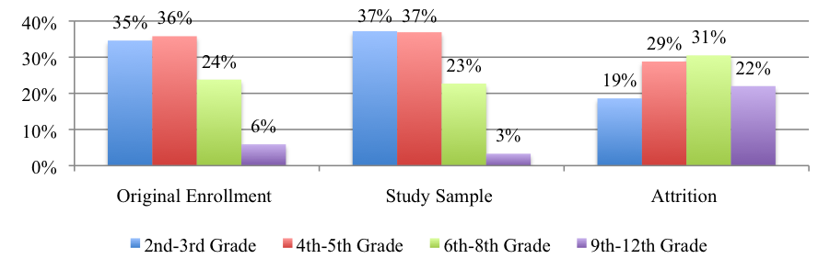

The students who were originally enrolled in the THINK Together SES program attended 36 schools. Of those 36 schools, 33 had at least one student attend the program at least once. There were also 36 original tutoring sites (including one “in-home” site); 33 of these sites also had at least one student attend. The number of students originally enrolled at each tutoring site ranged from 1 to 66, with an average of 11-12 students (11.5) per site. The class size (number of students who attended) ranged from 1 to 52 at each site, with an average of 10-11 students (10.4). The greatest number of sites had 1-4 students, with the majority of sites having less than 10 students. The following chart shows the class sizes across sites.

Chart 2: Number of Tutoring Sites, by Class Size

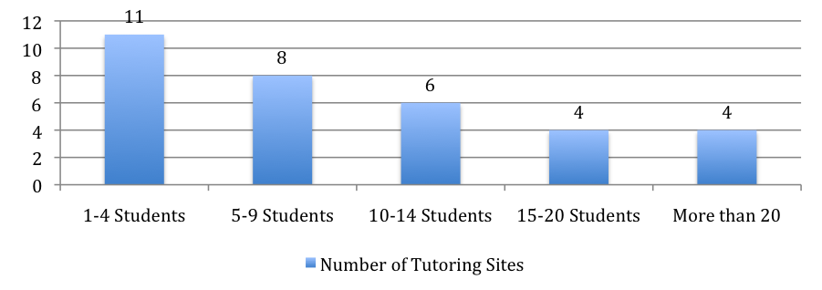

The following table shows, for each site, the number of students originally enrolled, the number of students included in the Study Sample (attended at least once or completed a survey), and the number of students who did not attend (Attrition). The sites are ranked according to the number of students originally enrolled, from greatest number of students to least. The Donahue Center had greatest number of students enrolled (n=66), followed by Los Puentes (n=35), Lowell Elementary (n=28), and Adams Elementary (n=24).

Table 5: Enrollment by Tutoring Site

 | Original Enrollment  (n=425) | Study Sample  (n=366) | Attrition  (n=59)
Donahue Center | 66 | 57 | 9
Los Puentes | 35 | 35 | 0
Lowell Elementary | 28 | 25 | 3
Adams Elementary | 24 | 23 | 1
McFadden Intermediate | 19 | 12 | 7
Remington Elementary | 19 | 16 | 3
Davis Elementary | 18 | 14 | 4
Martin Elementary | 17 | 15 | 2
Washington Elementary | 17 | 15 | 2
Heninger Elementary | 16 | 16 | 0
Spurgeon Intermediate | 16 | 14 | 2
Hoover Elementary | 14 | 14 | 0
Edison Elementary | 13 | 13 | 0
Garfield Elementary | 13 | 13 | 0
Pio Pico Elementary | 10 | 7 | 3
Wilson Elementary | 10 | 9 | 1
Roosevelt Elementary | 9 | 8 | 1
Saddleback High School | 9 | 2 | 7
Carr Intermediate | 8 | 8 | 0
Villa Fundamental | 8 | 6 | 2
Sierra Intermediate | 7 | 7 | 0
Walker Elementary | 7 | 7 | 0
Other/Unknown | 6 | 1 | 5
Lathrop Intermediate | 5 | 5 | 0
Monte Vista Elementary | 5 | 4 | 1
Lincoln Elementary | 4 | 4 | 0
Jackson Elementary | 3 | 3 | 0
Kennedy Elementary | 3 | 3 | 0
Romero-Cruz Elementary | 3 | 3 | 0
Valley High School | 3 | 0 | 3
Willard Intermediate | 3 | 3 | 0
Century High School | 2 | 1 | 1
Chavez Continuation High | 1 | 1 | 0
Fremont Elementary | 1 | 1 | 0
In-home tutoring | 1 | 1 | 0
King Elementary | 1 | 0 | 1
Sepulveda Elementary | 1 | 0 | 1

Attendance

How many THINK SES tutoring sessions did the students attend? How many students completed the program? Did attendance vary by gender, grade level, or tutoring site?

Attendance data were provided by THINK for 342 students. Surveys were received for 24 students who had no attendance data recorded (14 parent surveys and 10 student surveys). It is possible that parents completed surveys for students who never attended, but it is unclear how a student could complete a survey without also being marked for attendance. Although all survey data were analyzed and included in this report (see Student Survey Results), the 24 students without attendance data were excluded from the analyses in this section.

Among the students who attended the THINK SES program (n=342), the total number of sessions attended ranged from 2.00 to 34.19, and the average number of sessions was 27.00. The duration of each session was approximately 1.5 hours, so the total hours of attendance ranged from 3.00 to 51.28, and the average number of hours was 40.50.

Table 6: Mean Attendance (n=342)

 | Mean | SD
Number of Sessions  Number of Hours | 27.00  51.28 | 8.22  12.34

Of the 342 students who attended the program, almost 30% (n=105) completed 34 tutoring sessions (the maximum number of sessions). Over half of the students completed 30 sessions, and almost 75% of the students completed 20 sessions. Only 13 students (3.8%) attended fewer than 10 sessions. Overall, almost all of the students who chose to attend the program attended at least half of the sessions, and over half of the students completed almost all of the sessions. The chart below summarizes the distribution of students, by number of sessions attended.

Chart 3: Attendance

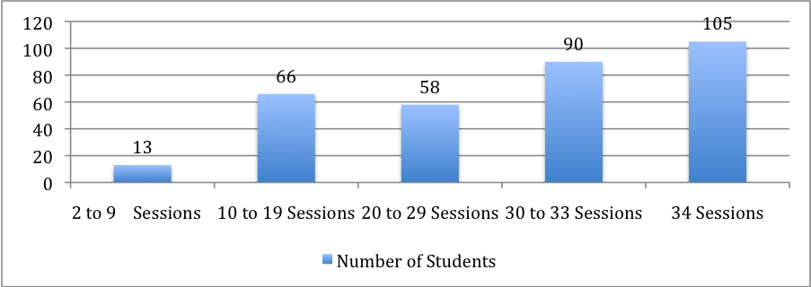

There was no significant difference in average attendance by gender; female and male students attended approximately the same number of sessions. However, the average number of sessions decreased by grade level. As shown in the chart below, younger students consistently attended more sessions than older students.

Chart 4: Attendance, by Grade Level

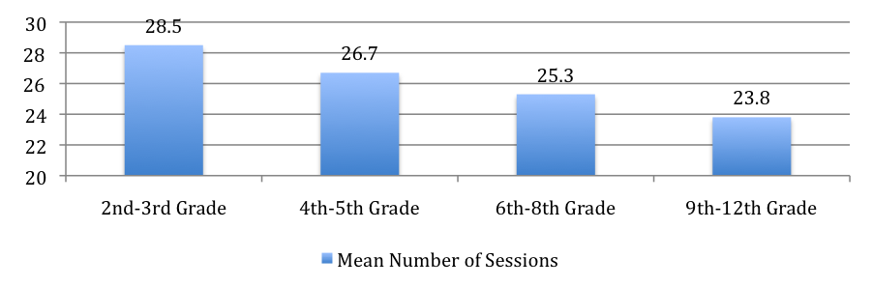

The average number of sessions per site also varied. There are many potential reasons for this, including the class size (number of students per site) and the type of school (grade level). There are also many potential program differences among the sites, which are not taken into account here. Nevertheless, among sites that are similar, it is informative to note the differences in average attendance.

The following chart shows the average number of sessions attended by the students at each site.

Chart 5: Attendance, by Tutoring Site

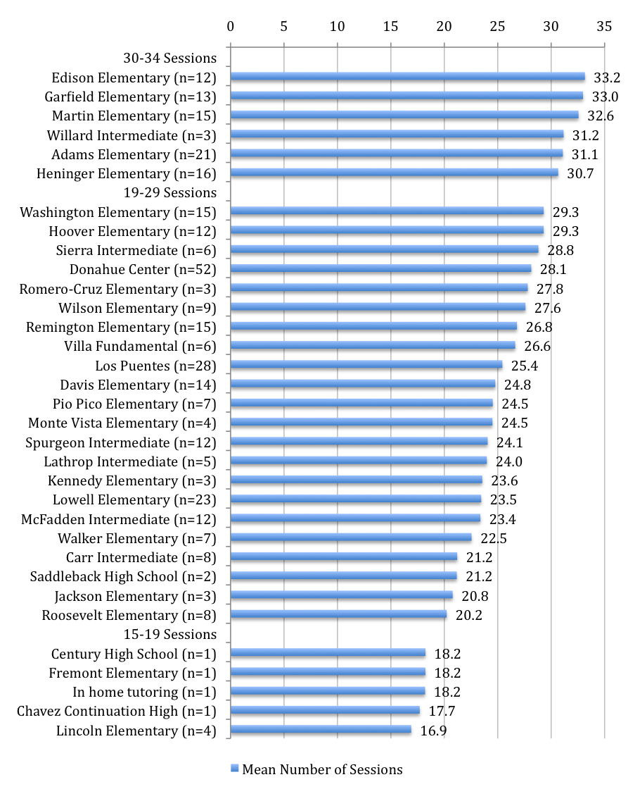

Findings: Student Surveys

This chapter summarizes the data collected from the pre-participation and post-participation student surveys. It includes a description of the analyses conducted with the data, and a presentation of the results of the analyses.

What were the student surveys designed to measure?

The student surveys were designed to partially address Performance Indicator #4 (relations with peers), Performance Indicator #3 (academic improvement in reading and math), and Performance Indicator #2 (completion of the SES program). Both the pre-participation and post-participation surveys included three sections: a measure of peer relations, three measures of perceived academic abilities; and a measure of reasons for continuing to attend the program.

The measure of peer relations had three scales: positive relations with peers; victimization by peers; and bullying of peers. The section of perceived academic abilities included three measures: school work habits; math efficacy; and reading efficacy.

How many surveys were completed?

All student surveys were administered by THINK SES program staff at each tutoring site. The pre-participation surveys were administed in January 2009 and the post-participation surveys in May 2009. 319 students completed a total of 515 surveys (227 pre-participation surveys and 288 post-participation surveys). 196 students completed both pre- and post-participation surveys. The administration of the surveys by THINK program staff raises issues of student confidentiality, as well as validity of the data and the results. Primarily, this first year of implementation helped determine the appropriateness of the surveys and the feasibility of administration. Although the results presented in this report are promising, they should be interpreted cautiously. In order to acquire data in a way that ensures confidentiality for the students and validity of the results, future surveys must be administered by THINK staff who are not involved with students at the tutoring sites, and must be submitted to UCI in a way that ensures student anonymity.

What analyses were conducted with the surveys, and what results are reported?

Several analyses were conducted to study program effects on the six identified outcomes: School Work Habits; Math Efficacy; Reading Efficacy; Positive Peer Relations; Victimization; and Bullying. Analyses were first conducted to compare pre-participation scores to post-participation scores, determining if there were significant change over time (pre to post) in any of the outcomes, and whether any of these changes differed by gender or grade level. Another group of analyses was conducted to determine the effects of program attendance (number of sessions) on any of changes in outcome scores, and whether the effects of attendance varied by gender or grade level.

Descriptive analyses were conducted to show any potential differences in outcome scores, due to type of tutoring received (group or individual). The last set of analyses summarized students’ reasons for continuing to come to the program, and compared the reasons to determine if any were more significant than any of the others.

1. Program Effects – Changes in Student Outcomes from Pre-test to Post-test

This section summarizes the results of analyses conducted to contrast students’ pre-test and post-test scores for six outcomes: School Work Habits; Math Efficacy; Reading Efficacy; Positive Peer Relations; Victimization; and Bullying. It also summarizes the pre-test to post-test differences in outcome scores, by gender and grade level.

Comparisons of Pre-test and Post-test Outcome Scores

Were there significant differences between students’ pre-participation scores and post-participation scores in student outcomes?

196 students completed both pre-participation and post-participation surveys. Mean scores for each outcome measure, pre and post, were calculated. Paired t-tests were conducted to determine whether there were any significant changes in outcome scores, from the time the pre-participation surveys were administered to the time the post-participation surveys were administered. Of the six outcomes, there were significant positive changes for three: Math Efficacy; Reading Efficacy; and Positive Peer Relations (p<.05). In other words, for the 196 students who completed the pre and post surveys, there was a perceived increase of efficacy in both math and reading, and a perceived increase in positive relations with peers. The following table shows the pre, post, and change scores for all six outcomes.

Table 7: Pre-Post Outcome Scores (n=196)

 | Pre-Participation |  | Post-Participation |  | Change, Pre-to-Post
 | Mean | SD | Mean | SD | Mean | SD
School Work Habits | 3.20 | .57 | 3.23 | .59 | .03 | .51
Math Efficacy* | 4.03 | .78 | 4.15 | .81 | .11 | .75
Reading Efficacy* | 3.40 | .83 | 4.11 | .87 | .16 | .87
Positive Peer Relations* | 3.74 | .93 | 3.88 | .97 | .14 | .82
Victimization | 2.29 | 1.01 | 2.26 | 1.06 | -.03 | .92
Bullying | 1.65 | 1.03 | 1.65 | 1.00 | .00 | 1.01

Pre-Post Differences in Outcome Scores, by Gender and Grade Level

Did program effects on students’ outcome scores (pre-to-post participation) vary by gender or grade level?

In addition to testing whether there were significant changes in the six outcomes over time (pre-post), analyses were conducted to test whether there were differential effects of time for different groups of students. Repeated measures ANOVAs were conducted to test for the effects of time. Since there were only three students in the 9th-12th grade category who had completed both the pre- and post-participation surveys, this category was dropped. The following table shows the distributions of the cases that were used in these analyses.

Table 8: Student Descriptives, ANOVAs

Female  Male | 89 (46.1%)  104 (53.9%)
2nd-3rd Grade | 75 (38.9%)
4th-5th Grade | 80 (41.4%)
6th-8th Grade | 38 (19.7%)

Similar to the results for the paired t-tests, results of the repeated measures ANOVAs showed that there were significant main effects of the program on pre to post scores for three of the six outcomes: Math Efficacy; Reading Efficacy; and Positive Peer Relations. There were also significant effects of grade and/or gender for five of the six outcomes: School Work Habits; Math Efficacy; Reading Efficacy; Positive Peer Relations; and Bullying. There was only one significant interaction effect: the effect of program (time from pre to post) and grade level on perceived Reading Efficacy.

The graph below shows how the interaction of time and grade level had an impact on perceived Reading Efficacy. There was an increase for students in the 2nd-3rd and 6th-8th grade categories, compared to a slight decrease for students in 4th-5th grade category (p<.01).

Chart 6: Interaction Effect of Time (Pre-Post) and Grade Level on Reading Efficacy
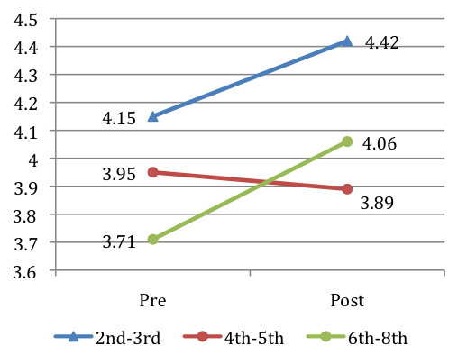

2. Program Effects – Effects of High and Low Attendance on Changes in Outcomes

Is the level of program attendance related to changes in student outcomes?

To answer this question, analyses were conducted to determine if there were any significant changes in outcome scores of two groups of students—those with high levels of attendance and those with low levels of attendance.

Amount of attendance varied greatly among the students who attended the THINK SES program. The number of sessions ranged from 2 to 34, and the average number of sessions was 27. The average was high because the distribution was skewed heavily toward the upper end—of the 342 students who attended the program, almost 30% (n=105) completed 34 sessions. Of these 104 students, 85 had also completed both pre and post surveys. This group of students (n=84) comprised the “high attendance” group.

To create a “low attendance” group with a comparable number of students, the distribution of those students who had completed both surveys was examined for a logical break. Based on this distribution, it was determined that the “low attendance” was comprised of those students who had completed from 2 to 25 sessions (n=52).

Table 9 describes the sample used in the following analyses.

Table 9: Student Descriptives, ANOVAs (n=137)

Low Attendance  (2-25 sessions)  High Attendance  (34 sessions) | 52 (40.0%)  85 (60.0%)
Female  Male | 63 (46.0%)  74 (54.0%)
2nd-3rd Grade | 54 (39.4%)
4th-5th Grade | 57 (41.6%)
6th-8th Grade | 26 (19.0%)

Were there differences in student outcomes associated with high vs. low attendance? Did the effects of attendance vary by gender or grade level?

Analyses (ANOVAs) showed a significant effect of high vs. low attendance on changes in School Work Habits, Reading Efficacy, and Positive Peer Relations, with differing effects by gender and grade level. Overall, the greatest positive effects of high attendance were for boys and for students in 6th-8th grade.

School Work Habits

Results showed that students who had attended 34 sessions had a greater positive change in School Work Habits than students who attended less than 25 sessions, with interaction effects between attendance, gender, and grade (p<.01). Boys who had attended 34 sessions had a much greater change than girls. The results were similar for different grade levels. Students in 4th-5th grade had a greater positive change than students in 2nd-3rd grade, and students in 6th-8th grade had the greatest amount of positive change in School Work Habits.

Chart 7: Effects of Low and High Attendance on Change in School Work Habits
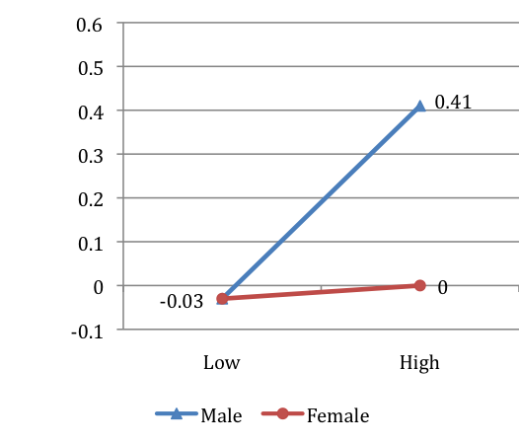 | 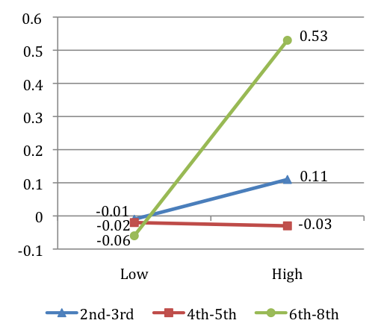

Reading Efficacy

Similar to the results for School Work Habits, these results showed that there was a significant effect of program attendance on Reading Efficacy, with a significant interaction effect between attendance, gender, and grade (p<.01). Boys who had attended 34 sessions had a much greater positive change in Reading Efficacy than girls. Results for grade level showed a significant positive change for students in 6th-8th grade who attended 34 sessions.

Chart 8: Effects of Low and High Attendance on Change in Reading Efficacy
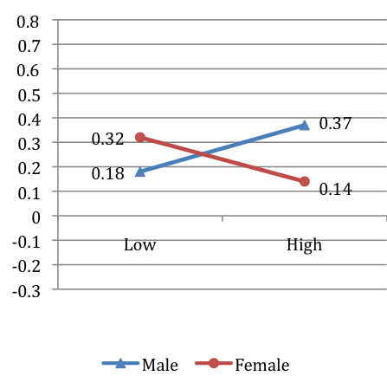 | 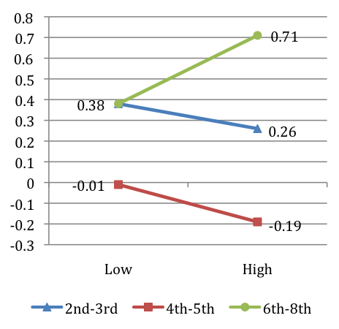

Positive Peer Relations

Results showed a significant effect of attendance on Positive Peer Relations, with a significant interaction effect between attendance and gender (p<.01). Again, boys who had attended 34 sessions had a much greater positive change than girls.

Chart 9: Effects of Low and High Attendance on Change in Positive Peer Relations
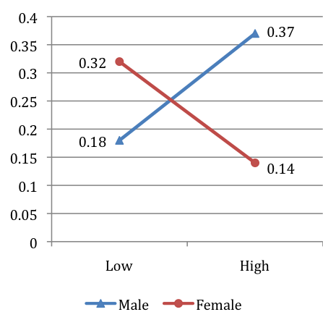

3. Program Effects – Effects of Tutoring Group on Changes in Outcomes

Did the type of tutoring have a significant effect on changes in any of the outcomes?

342 students attended the THINK SES program at least once, and of those students, most (n=295) received tutoring in groups. A small number of student received individual tutoring (n=38) and a few students received a combination of group and individual tutoring (n=9). Of those students who completed pre and post surveys, 158 received group tutoring, 28 received individual tutoring, and 7 received a combination of both.

ANOVAs were conducted to determine if the type of tutoring had any significant effect on any of the student outcomes. Of the six outcomes, there was only a significant effect of type of tutoring on victimization. For students who received group tutoring, there was a decrease in perceived victimization by peers. For students who received individual tutoring or a combination, there was an increase in perceived victimization (p<.01). Although the results should be interpreted with caution, due to the low number of students who received individual or combined tutoring, it is interesting to note that group tutoring may have a more positive impact on reduced victimization by peers than individual tutoring.

A descriptive comparison of the differences in outcomes and attendance, by type of tutoring, also shows that type of tutoring may have varying effects on different outcomes. Students who received only group tutoring attended a greater number of sessions than those students who received some (or all) individual tutoring sessions. Those who received only group tutoring attended an average of 31.2 sessions, while those who received some individual tutoring attended an average of 18.7 sessions. However, when comparing the change in outcome scores of these two groups, the students who had received some individual tutoring showed a slightly greater increase in math and reading efficacy than those students who had received only group tutoring. Although these numbers should also be interpreted with caution, they suggest that individual tutoring may be more effective for promoting efficacy in math and reading, even with fewer sessions.

Table 10: Changes in Outcomes, by Type of Tutoring
 | Group Only (n=159) |  | Individual (n=36)
 | Mean | SD | Mean | SD
School Work Habits  Math Efficacy  Reading Efficacy  Positive Peer Relations  Victimization  Bullying | .05  .07  ,13  .16  -.13  .01 | .54  .76  .86  .77  .94  1.03 | -.02  .29*  .28*  .04  .42  -.07 | .33  .70  .90  .99  .66  .90

4. Reasons for Continued Attendance

The last section of the post-participation student survey was designed to partially address the retention element of Performance Indicator #2. The four items asked students about their reasons for continuing to attend the THINK SES program. They were similar to those used on the pre-participation survey, which asked students about their reasons for initially coming to the program. The results from the items on the pre-participation survey were reported in the March 2009 report.

What reasons did students cite for continuing to attend the THINK SES program?

286 students responded to the last four items on the post-participation survey. Of these students, 87% reported that it was “True” or “Really true” that they came to the program because they wanted to do better in school. Similarly, 85% of students reported that it was “True” or “Really true” that they came because their parents wanted them to come. A majority of the students (73%) responded that it was “True” or “Really true” that they came because they thought the program was fun, and about half of the students (55%) came because their friends were there.

Chart 10: Reasons for Continuing to Attend (n=286)

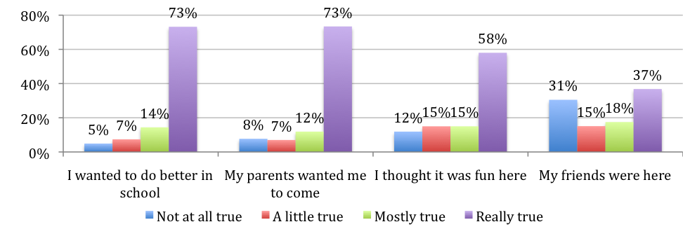

Findings: Parent Surveys

This chapter summarizes the data collected from the pre-program and post-program parent surveys. It includes a description of the analyses conducted with the data, and a presentation of the results of the analyses.

What were the parent surveys designed to measure?

The parent surveys were designed to address Performance Indicators #1 and #2 (initial enrollment and program completion), and to provide supporting evidence for Performance Indicator #3 (academic improvement in reading and math), and Performance Indicator #4 (positive relations with peers and adults).

The pre-program parent survey asked about reasons for initial enrollment in the THINK SES program. These results were reported in the March 2009 report. This report will summarize results from the two measures that were included on both the pre- and post-program surveys: a measure of perceived school performance and relations, and a measure of expected (pre) and perceived (post) program effects on academic skills and relations.

The measure of perceived school performance and relations included items that rated students’ academic performance (grades and abilities), as well as relations with peers and teachers at school. The measure of perceived program effects included items that rated students’ attitudes toward school, skills in math and reading, and relations with peers and teachers at the THINK SES program. (The Measures section of this report gives more detailed information about the parent surveys. The surveys are also included in the Appendices).

How many surveys were completed?

All parent surveys were distributed by THINK SES program staff by mail. The pre-participation surveys were sent in January 2009 and returned to each THINK SES tutoring site. The post-participation surveys were mailed out in June 2009 and returned to the THINK main office (also by mail). 231 parents completed a total of 272 surveys (205 pre-program surveys and 67 post-program surveys). 41 parents completed both pre- and post-program surveys. As with the administration of the students surveys, it is problematic to have the surveys collected directly by THINK staff. For the coming year, THINK and UCI will discuss administering the surveys in a manner that protects confidentiality, and also potential strategies for increasing the return rate of the post-program parent surveys.

What analyses were conducted with the surveys, and what results are reported?

Descriptive analyses were conducted to compare parents’ expectations for the SES program (pre-program survey) to the perceived effects and successes of the program (post-program survey). Analyses were also conducted to determine if there were any significant differences, from pre-program to post-program, in parents’ perceptions of students’ school performance or relations. Overall results showed that parents had a positive view of the effects of the program, and that there was positive change in students’ school performance or relations. Results are reported in the following two sections.

1. Program Effects – Expectations and Perceived Results of Participation

This section summarizes the descriptive analyses of parents’ pre-program expectations for the SES program, and their post-program perceived effects of program participation on their child.

Pre-Program Expectations

Parents had high expectations for the THINK SES program. The highest expectations were for improvements in their child’s reading skills, math skills, and attitude toward school. Over 95% of parents who completed this section of the pre-program surveys (n=190) agreed that they thought the program would improve their child’s skills in these areas. Of these three expectations, the highest was that the program would improve their child’s math skills.

Over 90% of the parents strongly agreed with the other three items. They thought their child would like the program and would get along with their teachers and peers. The lowest expectation was that their child would like going to the SES program. Overall, however, expectations were high for all six items, with 93% to 96% of parents choosing “Strongly agree”, “Agree”, or “Slightly agree” for each item.

Chart 11: Parent Expectations, Academic

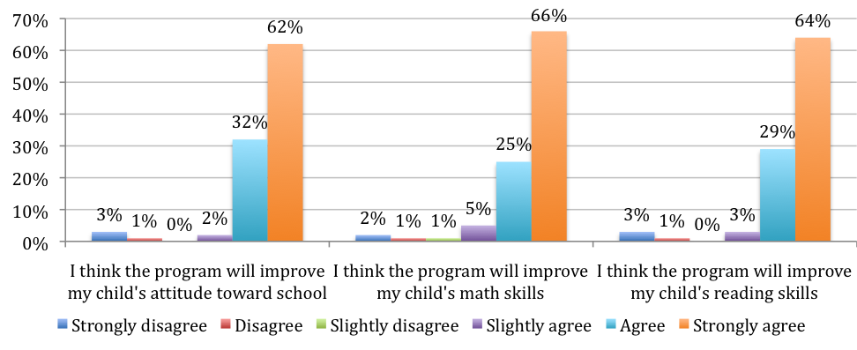

Chart 12: Parent Expectations, Relations

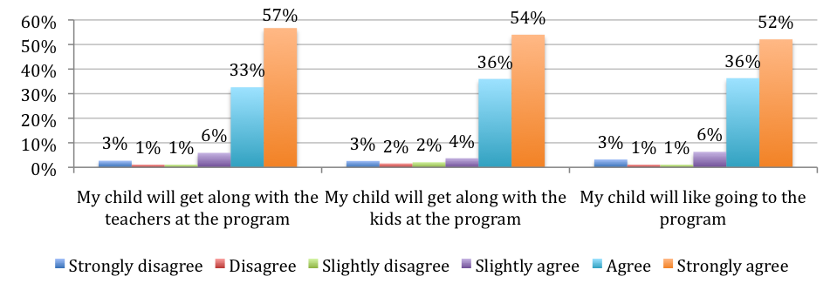

Post-Program Evaluations

Parents reported that the THINK SES program had a number of beneficial effects on their child. The greatest perceived results were for relations with teachers, followed by relations with peers, and an improvement in attitude toward school. Over 90% of parents agreed that the SES program had effects on these three areas, with approximately 60% choosing “Strongly agree”. About 90% of parents also agreed that their child liked going to the program, that the program improved their child’s math skills, and that the program improved their child’s reading skills.

Chart 13: Perceived Effects, Relations

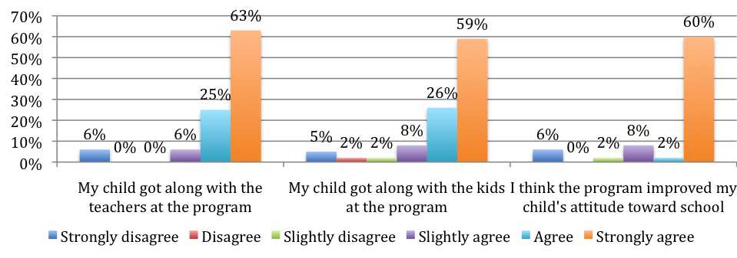

Chart 14: Perceived Effects, Academic

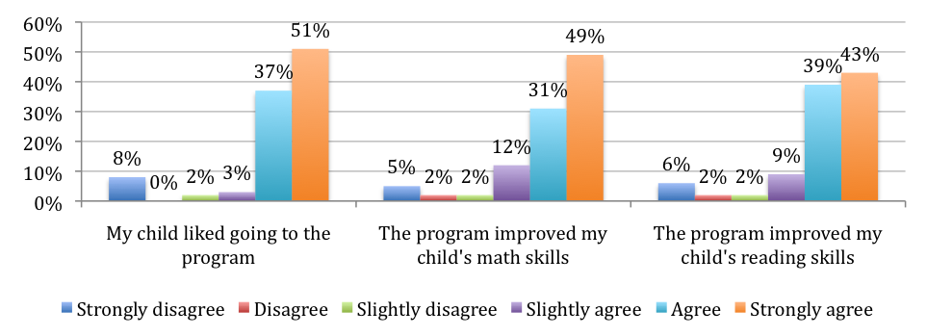

Were there any differences between parents’ expectations at the beginning of the SES program and the perceived benefits at the end of the program?

Parents had high expectations for the THINK SES program and also perceived strong benefits as a result of participation in the program. Analyses conducted with the group of parents who completed this section on both pre and post-program surveys (n=34) showed no significant differences between expectations and perceived benefits. For each item, over 90% of parents agreed that the SES program would, and did, have a positive effect on their child. A greater return rate of parent surveys would help substantiate the conclusion that parents, overall, perceived that the THINK SES program met their high expectations.

2. Program Effects – Changes in School Performance and Relations

Did program attendance have a significant effect on parent’s perceptions of students’ school performance or relations?

Parents’ post-program scores of students’ performance, behavior, and relations at school were compared to parents’ pre-program scores. Post-program mean scores in homework completion, performance in reading and math, and grades were overall higher than pre-program mean scores. Post-program mean scores in relations (following school rules, getting along with kids and teachers) were slightly lower or about the same. Examining the means of all seven items, from all pre-program (n=189) and post-program surveys (n=67), the post-program mean score was higher than the pre-program mean score.

Paired t-tests were conducted to determine if there was a significant difference between the pre-program and post-program scores. Only 34 parents completed this section on both the pre-program and post-program surveys, which is a very small sample in comparison to the total number of students. However, there was a significant increase in scores for math and reading, as well as an increase in the mean score of all seven items (p<.05).

Table 11: Pre and Post Mean Scores, School Performance and Relations
 | Pre-Program  (n=189) |  | Post-Program  (n=67) |  | Change Scores  (n=34)
 | Mean | SD | Mean | SD | Mean | SD
My child completes his/her homework | 4.72 | 1.36 | 4.92 | 1.17 | .12 | 1.67
My child is doing well in reading* | 4.06 | 1.41 | 4.54 | 1.20 | .68 | 1.59
My child is doing well in math* | 4.14 | 1.41 | 4.73 | 1.30 | .62 | 1.71
My child gets good grades at school | 4.31 | 1.37 | 4.61 | 1.23 | .09 | 1.49
My child follows school rules | 5.13 | 1.25 | 5.03 | 1.23 | -.25 | 1.37
My child gets along with kids at school | 5.17 | 1.23 | 5.07 | 1.21 | .10 | 1.19
My child gets along with teachers at school | 5.24 | 1.12 | 5.25 | 1.15 | -.04 | 1.32
Mean, all 7 items* | 4.64 | 1.04 | 5.23 | 1.15 | .52 | 1.32

Parent Interviews

Interviews of a total of 10 parents of students attending Hoover and Washington elementary schools and Carr and McFadden intermediate schools in SAUSD were completed after the conclusion of SES services (the last two weeks of May 2009 through the first week of June). Interviews took place at school sites and included one parent whose child attended Carr intermediate school but received SES services at the KidsWorks Donahue Center. Two mothers had children who did not attend the After School Program and only received THINK SES services. Two mothers had children who attended only the THINK after school program. Four mothers were interviewed individually and six mothers were interviewed in pairs (at the same time). The interviews lasted from 10 to 20 minutes; two were conducted in English and the rest in Spanish.

The key themes and concerns that parents expressed in these interviews are summarized in the following sections: 1) recruitment and communication with parents; 2) perceived benefits of their child’s Participation in SES; 3) suggestions for program improvement.

Recruitment and Communication with Parents

Parents were asked how they became aware of the SES program and why they selected THINK as their provider. Most of the parents stated that they found out about the SES program by a paper they received from school [a letter that is sent from the district to the home inviting parents to apply for Supplemental Educational Services]. One parent stated that she found out through a flyer that was sent home by the THINK after school program. One parent recalled:

Empezaron distribuir las solicitudes por medio de la escuela. Y a mi me parecía “Wow!” nunca había escuchado de eso es una gran oportunidad para los niños para que tengan mas ventaja y quizás puedan avanzar un poquito mas. They began to distribute the application through the school. And I thought “Wow!” I have never heard of such a great opportunity of the kids to have such an advantage and maybe advance a little more.

Two parents mention seeing the THINK booth at one of the SAUSD sponsored Information Fairs. Another parent stated, “I found out through the THINK Together after school program. They asked us if we wanted any of our kids to be tutored in any subjects they’re having problems with, and I took advantage of it.”

All parents interviewed said they selected THINK because they were familiar with the After School Program and because the services were offered on the school site which is supported by parent survey data reported above. In interviews parents were able to further explain how they came to make that choice. For those who had their child in the THINK ASP it seemed the most logical choice since their child was already at the school site in the afternoons. For working parents this fact was a key feature attributing to their choosing THINK. Parents elaborated on why they selected THINK to be the SES provider for their child:

- This is my first time so I am not really familiar in general with who does the tutoring thing [SES]. But in regards to if my kids in school have an opportunity for any tutoring classes then I take advantage no matter what. I picked THINK because it was here and my daughter is in the after school program, it’s local. Sometimes I get out of work very late so it’s kind of hard for us to have someone come over our house, or for us to go to the tutoring. But sometimes I don’t have enough time to help my kids with their subjects [in school]. So, it’s worked out pretty good for me.

- Escogí, “Pensando Juntos,” porque me gusto el nombre y por que ya estaba mi hija en el programa después de la escuela de THINK.

[I picked ‘THINK Together’ because I liked the name and because my daughter was already in the alter school program].

- Escogí THINK por que iba ser ‘one-on-one’ y porque iba estar aquí en la escuela.

[I selected THINK because they offer one-on-one and because it took place here at the school].

The parent whose child attends the SES program at KidsWorks explained that the KidsWorks staff contacted her by phone to inform her that her daughter was eligible for this program since she needed help in Math. She did not recall completing an application but that she was told that she could choose to receive the tutoring at the school site she attends or at the Center. Her daughter, a 7th grader at Carr, chose the Donahue Center because she and her older brother had attended their afterschool and summer programs since elementary school as they lived in the same apartment complex where KidsWorks first started. She pointed out that the support of the KidsWorks staff was central to her finding out and pursuing SES services for her child. Although she had received the SES informational letter in the past, “Lo leí pero nunca puse atención que era, nunca lo había tomado, yo no sabia […] Ellos se encargan allí [en KidsWorks] Es un centro de comunidad y les ayudan mucho a ellos allí.” [I read it but I never paid attention to it, I never applied, I did not know. They take care of it there [at KidsWorks]. It is a community center and they help the kids a lot there].

Another parent whose child is in the THINK ASP explained that she did not recall receiving any information about the SES program and that she had only now heard of it, but was very interested in applying since her daughter is behind in Reading and Math. She explained why she viewed such services as valuable:

A ella le gusta leer mucho y uno de mamá que no se preparo por que antes era distinto a lo que hoy se necesita aquí en el estudio. Pues yo a veces no le puedo ayuda a la niña en la tarea. Y por eso hay veces que se atrasaba, y entonces cuando vi este programa si me gusto mucho y se lo explique a la maestra que me ayudara de que mi niña se quedara y si me ayudo. Para mi es muy importante que siga aprendiendo y reciba la ayuda que necesita.

[She likes to read a lot, and one as a mother who did not prepare since here it is different from before [with regard to] what one needs to study. I sometimes can not help my daughter with her homework. And for that reason sometimes she gets behind and so when I saw this program I liked it a lot and I explained to the teacher that she should help me so that my daughter can stay and she did. For me it is important that my daughter stay and get the help she needs].

One parent had applied for SES services but did not receive them because her daughter was in 1st grade. She came to the interview since she was interested in finding out more about the program. She was never informed that SAUSD did not serve 1st grade students through their SES program, nor did the THINK Site Coordinator who encouraged her to apply know that this was the district policy. She applied but never got any kind of notification either way. When she inquired with the site coordinator she was given a phone number to call at the district. She explained, “I never got a response. I was the one calling and finding out and that’s when I talked to a lady and they told me that supposedly they were not going to do that for Hoover [serve 1st grade students]. The parent expressed frustration that her daughter was unable to get the services she sought with out any clear explanation as to why that was the case.

From their perspective, parents voiced confusion and misinformation about how the SES program worked. For example, one parent talked about how she had thought that she would not qualify for SES services and that the language on the application was too complicated, which dissuaded her from applying in the past. She pointed out that the question on the application that asks if the child receives Free/Reduced Lunch [FRL] might make parents think that if they do not receive FRL then they do not qualify for either the after school program or SES, and might opt not to complete the application. In her words,

Fue algo que mire yo y dije, “¿Para que voy a perder mi tiempo?” La aplicación decía eso, si tu agarras gratis lonche… como que automáticamente te van a eligir; así que yo dije, “Si no cualifico para lonche, entonces porque voy a llenar la aplicación?”

[It was something I looked at and said, “Why should I waste my time.” The application said that if you get free lunch then you will automatically be selected, so I said, “If I don’t qualify for free lunch then why would I fill out the application?”].

Later, THINK staff informed the parent that she should go ahead and complete an SES application. In this case, if the THINK staff had not been proactive in informing parents about the SES program this student would have lost the opportunity to receive tutoring.

Parents were asked to give suggestions about how THINK might have better outreach to parents to inform them of the opportunity for SES services for their child. The experiences related by several of the parents interviewed spoke to the limitation of sending SES information in writing or through the mail. Many immigrant parents do not comprehend the information about the program or how they can apply, or how the districts’ selection and provider assignment process works. One parent, who also works as an Activity Leader in the THINK after school program, noted that parents, in her experience, were more responsive to verbal face to face communications:

Quizás porque talvez los papas ven los papeles pero no los lean, necesitan mas bien verbalmente que usted les diga “Oye, mire esto…” Por ejemplo, si les doy un papel a los niños, ellos no lo llenan o no tienen tiempo, se les queda atorada en la mochila. Sin embargo, cuando les decimos, ‘Mira señora… [y se lo explicamos] lo entregan rápidamente. Una de las cosas que me gusto que estaban haciendo es que tuvieron un pequeño escritor en el parque por donde pasaba toda la gente…y por eso quizás este año hubo mas respuesta. Más publicidad verbal. Ya ve que hay tanto que leer que llega a casa, y uno trabaja, llega tarde y no te da ganas de estar leyendo todos los papeles.

[Maybe because the parents see the papers, but they don’t read them, they actually need someone to tell them verbally, “Oh look at this…” For example, if I give the children some papers they don’t fill them out and they don’t have time, they get stuck in their backpacks. However, when we say, ‘Look Mrs. … [and explain it] they turn it in quickly. One of the things I liked was that they had a little booth at the park where everyone goes by…and perhaps that is why this year there was a greater response. [We need] more verbal publicity. You see that there is so much that one has to read that comes home and then one works, gets home late and you don’t feel like reading all those papers].

In interviews THINK Together Site Coordinators concurred with this perspective regarding the limitations of communicating with parents in writing. Two Site Coordinators commented:

- I think it is parents not paying attention to the information being provided to them, when the district sent out those registration forms through the mail. What I heard was they didn’t even realize they got that in the mail. Quite a few parents came to me, “I didn’t get this application yet.” They didn’t take the time to read it or look at it, because there were quite a few parents who came up to us asking, “Where can I get the application?” And I had to keep telling them, “It was mailed to you by the district.” —THINK Site Coordinator

- Sending the SES applications home with the students is not, I think, a very efficient way of getting that to the parents. I think the school kind of dropped the ball delivering those applications to the hands of a parent. And it was sent out very late, and that’s, I think, a district-wide thing, that those applications were sent out very late. And there was a very small window of time for kids to get them in. And [the deadline] was like a week or something like that. And some kids, you know they’re going to keep it in their backpacks for two weeks, or forever, or throw it away.
—THINK Site Coordinator

Also emphasizing the issues related to communicating with parents in the Santa Ana community, another site coordinator spoke to the confusion some experienced with the SES application process and how that might have prohibited them from receiving the provider of their choice. She explains:

After the registration period was over, a lot of the parents would come up to me and asked me, “How come we didn’t get THINK Together? We got assigned to another provider.” And I think it’s because they did not specifically put THINK Together on the application or they neglected to put anyone at all. So maybe the district chose for them – I’m not exactly sure how that works. But we did get several families that said, “How come THINK Together wasn’t assigned to us? We got assigned to another organization.” So I think it’s because when we sign up our kids in the regular after-school program, we help the parents fill out the application – a lot of them struggle with this, with writing. So we would tell them, “Okay, this is where you put it.” And we couldn’t do that with SES.
—THINK Site Coordinator

Parents’ Perceived Benefits of their Child’s Participation in SES
The mothers interviewed were asked to share their expectations and experience with the THINK SES program and to comment on any benefits that they had perceived for their child that resulted from their participation in the SES tutoring. All the mothers stated that they had expected the program to help their child to do better on their homework and with the academic subjects they were struggling with in school and all believed that the tutoring indeed had positive results for their child. For example, a mother affirmed that her child did reap academic benefits from the SES experience saying, “Si, porque antes era muy lento, como que le costaba y ahora no. [Yes, because before he was very slow, as though it was hard for him and now it is not]. Similarly, another mother reports on positive results for her son:

Antes necesitaba mas ayuda y ahora ya que llegaba se veía que sabia un poquito más de lo que sabía anteriormente. Mire que si estaba mejorando. En las calificaciones no sabias decirle porque no había mirado, pero lo que miraba cuando estaba haciendo su tarea, miraba la diferencia. Y a el le gustaba mucho, estaba el contento.

[Before, he needed more help but now when he gets home you can tell that he knows a little more than what he knew before. I saw that he was improving. I couldn’t tell you if in his it was in his grades because I haven’t seen them, but I could tell from when he does his homework, I could see the difference. And he liked to do it and he was happy].

The mother of the student at KidsWorks expressed appreciation for the support in motivating her child to focus on academics, she felt less alone in the effort. She was able to observe improvements that she believed resulted from her daughter’s participation in the SES program. She stated: “Pues, ella iba un poco mas baja y parece ahorita subió un poquito mas, y le iba mejor.” [Well, she was performing kind of low and it looks like now she has gone up a little more and she’s been doing better]. She attributed this progress to the more individualized attention given in the SES tutoring sessions which her child needed:

La verdad si les ayuda, pues ella decía que no entendía nada, que el maestro si le explicaba pero no le explicaba bien, o no se, de tantos niños que hay [en la clase] no es que se van a sentar a explicarte bien. En los grupos pequeños aprenden más.

[The truth is that it does help them, she was saying that she did not understand anything (in class), that the teacher would explain it to her but would not explain it well, maybe because there are so many students [in the class], it is not as though they can sit down and explain it well. In smaller groups they learn better].

Parents observed how their children got better grades and gained greater confidence in their academic abilities. One parent, for example, who enrolled her child in SES to improve her performance in math stated that her daughter particularly liked the one-on-one tutoring that she received and reported that it did greatly help improve her grade in Math which went from a “D” to an “A.” Another parent—who also worked as a THINK Program Leader at the site where her child attended both the ASP and received SES services—explained how the SES tutoring was helpful to her as a parent with a child who is having difficulties in school, helping her daughter learn to be more independent and self confident. She elaborated:

Yo soy la mamá y ella me ha dicho, ‘tu no eres la maestra tu eres mi mamá’. En casa la apoyamos y la ayudamos mucho pero en si como que la sacudamos con tanto que queremos ayudarla. Entonces en este programa yo mire que avanzaba mas de que cuando yo estaba allí endentando ponerla toda información que ella necesitaba. Y veo que ya esta más independiente, ella sola hace las cosas, yo la siento más segura porque ahora ella puede leer más fácil y más rápido. Entonces ya se siente con la confianza de que puede hacer las cosas. Cosa que anteriormente no lo hacia. Yo pasaba una hora [intentando ayudarla] pero ella no ponía la atención, me miraba como si fuera una mama. Entonces al ponerla en [SES] le funciono mucho mejor por que ella esta escuchando lo que dice una maestra, no la mamá.

[I am the mother and she has told me that you are not my teacher you are my mom’. At home we support her and help her a lot but it is as if we suffocate her with all that we want to help her. So with this program, I saw how she progressed, more so than when I was trying to give her all the information she needed. And I see too that she is more independent, she does things on her own, I feel that she is more confident because now she can read with greater ease and speed. So now she feels like she has the confidence to do things. That’s something that she didn’t do before. I would spend an hour [trying to help her] but she paid no attention, she would look at me like a mother. So once I put her in [SES] it worked much better because she was listening to what a teacher said, not mother.]

This parent was very articulate in expressing her satisfaction with the program from an informed perspective as she would stop by the SES class and speak directly with the THINK Instructor working with her child. She was happy that her questions were answered and the Instructor was able to show her what they were working on and how her child was progressing: “Ella me mostraba las evaluaciones que les hacían y también leía el reporte que le ponen una meta, y me decía lo que estaban trabajando. Me contestaban las preguntas que yo tenia.” [She would show me the assessments, what they were doing and would read me the report that indicated the goals and she would tell me what they were working on. She would answer all the questions that I had].

All parents confirmed that their child completed their SES sessions, with a few indicating that they had received letters notifying them that they had missed some days. However they were not sure if they had made up those days in the end. One mother reported that her son missed some tutoring sessions due to a conflict with his soccer practice schedule. She explained that her husband had threatened to pull the child out of soccer if his grades did not improve, she reported that in “Math the subject he was receiving SES tutoring in, his grade went up to a “B”, although his got a “C- in Science.”

Suggestions for Program Improvement

In general parents expressed satisfaction with the quality of the SES tutoring THINK Together provided and said that they would enroll their child in THINK SES again. However they also offered suggestions for improving the program including starting sooner and making the groups smaller, as exemplified by these two parents’ statements:

- Yo lo recomendaría a todos los padres. Nada mas que si fuera posible que los grupos fueran mas pequeños y se tendrían la posibilidad de empezar las sesiones mas temprano seria fabuloso. Que empezaran cuando empiezan las clases y las maestras pudieran evaluar quienes necesitan esa ayuda. Entonces que empezaran a venir los tutores eso seria muy bueno para los niños. Toma mucho tiempo hasta después de navidad. Empiezan en enero y entonces y queda poco tiempo. Seria mejor si colectaran las aplicaciones durante el verano y ya para el otoño ya estuviera todo preparado. Seria muy beneficioso.

[I would recommend it to all the parents. The only thing is that it would be fabulous, if it were possible, for the groups to be smaller and that they start the sessions earlier. They should start when classes begin and the teachers could evaluate who needs help. Then the tutors could start coming, which would be good for the children. It takes too long, until after Christmas. They start in January and then there is little time left. It would be better if they collected the applications during the summer, and then by fall everything would be prepared. That would be very beneficial].

- Pienso que si los grupos fueran de tres niños por tutor seria mucho mejor. Porque los niños necesitan mucha ayuda en general. Ahora tienen cuatro o cinco. Yo pienso que si fueran tres niños por persona aprovecharían más porque los que están en esos programas son los que necesitan mucha ayuda en matemáticas y lectura…con los grupos mas pequeños los niños avanzan más.

[I think that if the groups were made up of three students per tutor it would be much better, because the children need a lot of help in general. Now they have four or five. I think that if there were three students per person they would be able to take more advantage [of the tutoring] because the ones that are in this program are the ones that need a lot of help in mathematics and reading…and with the smaller groups they advance more].

Two parents at one site commented on the need to provide adequate space for the tutoring sessions. One suggested that the program would improve if they provided a room with greater privacy where other students in the After School Program can not easily come in and interrupt the tutoring sessions. She also recommended that parents and students be informed of the location of their tutoring session on campus before the first day. She explained how they had to look all over the campus for the classroom on their first day as no one could tell her where to go. At first they were holding the SES session outside at the lunch tables where the noise of other students made it difficult for her child to concentrate. “Estaban dos semanas allá fuera, imagínate con todo ese ruido que hay allí, y ella batallaba” [They were out there for two weeks, imagine with all the noise there is out there and she would struggle], a mother complained. When the SES sessions finally moved into a classroom, other students on campus were still being disruptive of the SES sessions [a parent reported]. This occurred at an intermediate school site where the Site Coordinator had not been made aware that it was their responsibility to secure a space for the SES program and when a room was assigned it was right at the entrance of the school were there was a lot of foot traffic.

The issue of student engagement and appropriate level of challenge of the SES sessions for individual students was brought up in one of the interviews. The parent said that her son complained to her about having to go to SES making it difficult for her to get her child to attend: “Es que esta bien aburrido ama…” [It’s just so boring mom], he would tell her. “Y le dije que ‘te tienes que aguantar’” [And I told him ‘you need to hang in there.’] she said that she would respond. The intermediate school boy, who accompanied his mother to the interview, stated that he was “bored” in the SES sessions because they were “teaching me stuff I already know.” The student then insisted that he did not need help with anything and did not want to enroll in SES next year even though his mother said she intended to apply again because, as she explains, “A mi me gusto por que están aprendiendo, y siempre que se trata de aprender esta bien” [I like it because they are learning, and whenever it has to do with learning it’s a good thing].

Another parent at the same school stated emphatically that “Yes” her child had finished her tutoring sessions and that “she enjoyed it too.” These anecdotes along with some of the remarks made by principals and observational data collected, point to the need to make the quality of the SES experience students receive from THINK consistent across sites, and that the tutoring sessions need to be designed more intentionally to target the specific learning needs of students as indicated by the principal and teacher observations cited in the next section below.

One parent pointed out that THINK needs to be more consistent in their follow through with parents. She expressed disappointment that she never received the backpack, sweatshirt and gift card that was “promised” to her child for returning the SES enrollment paperwork. Another parent at the same site confirmed that she had received hers but that her son, (a 7th grader) was embarrassed to use it because of el foquito (the little Light bulb THINK Together insignia) on the backpacks distributed, suggesting that perhaps different incentives be provided older students.

Parents whose children also attended the THINK After School Program gave positive feedback on the quality of the experiences their children were having in that program. A few noted that they had previously pulled their child out of the program before when a Teacher was leading the after school program prior to THINK’s managing it this year. To this effect, one mother related the following:

A mi hijo también le gusto mucho, porque en el programa que había antes me decía ‘mami no quiero ir, saca me,’ y no podía porque trabajaba, y ahora que vino THINK, me dice, ‘Hay mami, ¿ porque me recoges tan temprano?

[My son likes it too, because en the program that they had here before he would say to me, ‘Mom, I don’t want to go, take me out of here,’ and now that he is coming to the THINK program he says, “Oh Mom, why do you pick me up so early?”].

Another parent also remarked that the THINK program had improved at that site from previous years when she had her daughter in the program but pulled her out. She is now satisfied with the quality of the THINK Together afterschool program and professionalism of the staff:

Antes el programa de THINK no estaba tan bien como esta ahora. La saque porque no me gusto. Agarraban mucha ayuda de las ‘lunch ladies’, entonces ellas no les podan ayudar en la tarea, y ahora son puras personas profesionales, maestras. Ha habido una mejoría bastante.

[Before the THINK program was not as good as it is now. I took her out because I did not like it. They would hire the ‘lunch ladies’ and they were not able to help them with their homework, and now they only have professional people, teachers. It has improved significantly].

In the next section, principals echo many of the concerns expressed by parents and provide further insight into the quality of the THINK SES and After School Program provision and offer their own suggestions for improvement and perspective on the potential benefits of a blended SES/ASP approach.

Principal Interviews

The principals from all 13 sample sites were contacted, initially through an email letter of introduction sent out by the THINK Santa Ana Regional Director, and then by phone and email by UCI researcher, Dr. O’Cadiz. One principal responded by email with the following: “Unfortunately I have not had much contact w/ the SES program here and cannot speak from observation or experience.” After multiple attempts at scheduling phone interviews with each principal, five interviews were successfully completed between May 12 -29, 2009, after SES services had concluded at their school sites.

Principals were asked questions regarding their experience with the first year of THINK SES services being provided to students at their school site. They were also asked about their satisfaction with the After School Program. Suggestions for how THINK can better serve their students needs and how they can improve the program were solicited, specifically in regard to parent outreach. Finally they were asked to share their thoughts on the proposal to create a blended SES/ASP approach and the benefits such an approach would have for their students.

All five principals indicated that they had little or no contact with the THINK SES tutors or Lead Teachers during the program’s operation at their site (three stating that they only had a chance to stop by once to briefly observe a session), one stated she “did not have time,” and another “I didn’t get a chance.” They all made it clear that they viewed the SES program and the providers as external to their schools’ academic intervention efforts, as reflected in the following statements from interviewed principals:

- I am not very involved. I have a Site Coordinator that oversees everything; otherwise I would get more involved. SES is not overseen by the school but provided by outside agencies that are paid by the district [to tutor students].

- It’s kind of like the US policy towards Gays in the military: ‘Don’t ask, don’t tell’; There were no concerns whatsoever and nobody had anything to ask or tell me about, it just sort of happens. In general that’s how SES has gone in my experience with all providers.

- I did not have very much control over what was going on in the [SES] classroom. I did not have much contact with them [the THINK SES tutors and Lead Teacher].

Principals were asked if they had any issues or concerns with the SES program’s organization. They all stated that there were no real issues that arose. One principal was particularly at ease with how the program operated at his site given that one of two of Lead Teachers overseeing the program were working at his school (one was a resource teacher and the other a teacher and former district afterschool program coordinator). He remarks accordingly:

I think it did pretty well for the first year. I was fortunate here because the person that was coordinating that particular aspect of the program happened to be a staff member here. That made it work so much better. I don’t know if it would have gone as fluidly if it was an outside person.

At one school, the THINK Site Coordinator—having recently replaced a school teacher who previously ran the after school program at that site—was leaving at the time the principal interview was conducted. As a result, the principal commented that communication with THINK staff had been limited. “They never spoke to me […] No information has been shared with me what so ever. I just knew that they were working here, but I was not aware of the intervention that they were using.”

On the other hand, one of the principals who was able to stop by the SES program expressed satisfaction with the quality of the THINK tutoring services based on brief observations of the program.

The instructors seemed very on top of what the kids were doing. They seemed to be focused on the needs of the kids and kept very good control of the groups. The kids seemed motivated and interested in what they were doing. So overall I had a very good impression of the program.

A principal who was interviewed in the final weeks of May indicated that he was pleased with the program, particularly since THINK had provided information about the progress of the students who completed the program. He stated, “I think it went well. They gave me a report—which none of the other groups have done—on the progress of the students.”

Four of the principals responded positively to questions about their communication with the THINK site coordinator and their satisfaction with the quality of the after school program, and said they were kept abreast of program goals and activities.

- [My experience with the ASP is] very positive, [the site coordinator] is very much on top of what’s going on. He communicates a lot with the teachers. If a student has a particular problem on a certain day, he keeps them aware of what happened in the afterschool program with any of the kids. He spends time in the classrooms; he has a good rapport with the kids and he has constant contact with the teachers. [He communicates] very regularly, he checks in every day with me. I am pretty happy with the whole after school program. It’s going pretty well here.

- I think they are doing a good job. It all boils down to the Site Coordinator. Our last Site Coordinator was very good. Everything was in place so I could just rely on her. She took care of every single thing. THINK Together is a good program, but if you have somebody who is good coordinating it, that really enhances the program.

- We’ve been very very [sic] happy having THINK Together here all these years.

One of the challenges in implementing the SES program that principals identified was space. This issue also arose in the site coordinator and parent interviews and is illustrated in the following principal’s statement:

Because I am already using 6, 7, 8 rooms for THINK and our own tutoring, which I had as many as 18 teachers tutoring, and then I had five providers [at my site], I mean they were in nook and crannies and on the floor, so it was very difficult. I wouldn’t stop from doing it because any extra individual help is going to be okay, it’s better than nothing. But that’s a challenge for us because we don’t have a lot of space, and I think teachers don’t want their rooms used [because] what happens is things get taken and stolen and broken and they just do… with the THINK After School Program not necessarily the tutoring. I have to constantly rotate the rooms. It gets crazy.

This issue of lack of space was also noted by parents as negatively impacting the experience of their student in the SES program, as indicated in interviews cited above.

Principals were invited to share their thoughts, as educators, regarding the proposal to create a comprehensive afterschool approach that intentionally coordinates the provision of the ASP and SES services, particularly with regard to the potential benefits of such a blended approach in helping to meet the academic needs of students. Most of the principals interviewed supported this proposal as expressed in the following reflections:

- I think it will work out fine, as long as the children that are in SES are also enrolled in the ASP. Some parents, either because of space aren’t able to get their kids enrolled in the SES program, or they don’t want them to, but they might want some tutoring. So I think that for the kids that are already in the ASP it’s a seamless opportunity for them to extend their learning. And I believe that with the tutoring that I observed in the room where they were doing it—they’re getting a much more intensive approach to instruction than they would in the regular afterschool program where they’re mostly getting the homework assistance and some enrichment stuff, but the level of it is certainly more directed to the needs of the kids in the SES aspect of it.

- Yes, I think it is benefiting students a lot. [THINK supports the goals we have for our students] through homework assistance and enrichment activities, where the students would other wise just stay at home doing nothing. We are serving close to 200 kids so that’s a good chunk of our student population. Also what you are doing is serving the most needy students. So that’s the value of it.

- I believe in the potential for both SES and ASP to make a significant difference in the education of our students. I just don’t feel like the programs have lived up to their potential. But I hold on to the faith that they’ll get much better.

- Definitely they need the additional support because the students that are coming [to our schools] they are not at grade level so if they need additional support, any program that offers that is a good thing.

One principal was less optimistic, and explained why:

First of all, the students that are selected for THINK is one set of students. Students filling out the forms for the free tutoring, the district selects those students. We don’t. So the district gets all the children that have signed up…now unless they go through and coordinate and say, now these are the kids that were in THINK that also signed up [to receive SES]…but see there you have different criteria to select those students […] I think that would be a difficult process to do. To me it’s a little bit, probably [like comparing] apples and oranges […] I don’t know what the purpose would be with coordinating it.

This principal continued to point out the various intervening factors that make it difficult to assess student progress and attribute it to their participation in THINK SES. The principal argued:

The problem is you are going to have all these factors…we have our own tutoring which we think is probably the best of all the tutoring because of it being specific […] We level, and we have intense [tutoring with] credentialed teachers, some of those are THINK kids that you would have in your [SES sessions] Then you have three or four other companies [providing SES services], you would have to be careful assuming that ones that had [THINK SES] were better; [or] for example, maybe they didn’t do as well, but that wouldn’t be necessarily a fault of the THINK SES.

The principal elaborated on why and how her school site maintains its own rigorous tutoring program, using their categorical funding, despite the availability of outside SES tutoring services, as do—according to this principal—some other schools in the district that choose to use their funds for that purpose. She explains:

On top of the five SES providers [at our site] we were tutoring 187 kids, so some of our kids got double tutoring. See, the very first year that they had the SES and we had our own tutoring we found that the SES—and I’m talking about any of the providers—were not very successful. We choose certain criteria and we don’t care whether they’re in THINK [ASP], or THINK SES or anything else. We just take the 187 or 200 however many we can tutor, [and offer] an intense after school tutoring program with pre and post, with 30 hours and then an additional 30 hours, where you’re seeing specific curriculum with our credentialed teachers here at school.

This principal strongly believed that the school’s tutoring was much more effective than what she had observed in general with all SES providers who she said grouped students heterogeneously both by grade and skill level, putting “far below basic and basic together.” Regarding such practices she concluded, “You can’t tell me that’s going to be effective!” The principal further argued:

Once we learned that we couldn’t rely on the SES to be effective we don’t even look at [SES providers’] data. We pick who we pick regardless of whether they’re in SES, so they can have both. And we see so much growth with ours! Now that doesn’t mean that [participation in SES or ASP] hasn’t added in, or helped [students progress academically], including the THINK program.

Suggestions for Program Improvement

Principals offered various suggestions for improving the SES program with regard to several aspects of the program, including: 1) outreach to parents and meeting students’ language needs; 2) communication and coordination with school; 3) alignment with standards and academic development needs of students

Specific suggestions principals made in these areas are outlined below.

Outreach to parents and meeting student language needs

Suggestions for how the THINK program could better outreach to parents about the SES program were requested from each principal interviewed. They were asked to respond in the context of what they are already doing at their site to inform parents about the SES program. Principal responses varied on this aspect, some stating that they actively encourage parents to apply for SES, or have teachers recommend students, while others seem to view the dissemination of information on the SES program as a responsibility of the district. Here is an example of a principal whose stance is proactive:

We really encourage our parents to apply for SES whether or not the kid might be eligible or not, because we wanted them to have as much opportunity as possible. So I think just providing more information about the component of the SES program through THINK Together would be helpful, because it was their first year with it and it wasn’t very publicized, although there is a fine line between what they can do and what they can’t do. But I think that from this point on they can really make a little bit more of an impact by sending [information]—what ever they can do within the legal ramifications of it—letting parents within the ASP know that the SES program does offer supplemental services to kids that goes above and beyond what they would get during regular ASP.

On the other hand, some principals did not consider any additional effort to advertise the SES services as desirable or even allowable. They viewed the SES program as the responsibility of the school and/or district. This perspective is conveyed in the following responses:

- Actually the District does that. There is a pamphlet that goes out at the beginning of the year and there is a certain amount of time that they can enroll. And also teachers encourage parents to sign up for that as much as possible. But you [the providers] are not allowed to give any information on who to select.

- The students are referred by the teachers. We have a waiting list, so I don’t think we need anymore outreach because we have more students than we can serve. Those students that need it the most have priority based on teacher recommendation, why should we advertise it anymore if we have far more than we can serve.

Principals also pointed out that that an effort needs to be made to match non-English speaking students with bilingual tutors. Indeed, non-English speaking students were observed as being matched with non-Spanish speaking tutors. At one intermediate school site, the site coordinator had advised a newcomer students’ parent to apply for SES. But then the student was matched with a tutor that did not speak Spanish. The student could not comprehend the math tutoring sessions and required a bilingual peer to translate for her. She became frustrated and stopped attending the SES sessions. At another site, a tutor was observed struggling to write a note to a student’s parent. The student was Spanish speaking and the THINK SES Instructor could barely communicate with him, much less with the student’s parent. With regard to this issue, the principal at that same site commented:

If the tutors don’t know how to speak Spanish then they are not going to be able to communicate with the parents. So I don’t think your people were bilingual and maybe that’s something you could look at. We have no problem communicating with our parents because we’re bilingual and speak Spanish so that is what I would ask you. I don’t think that the people that you brought were bilingual, and they were even having problems talking on the phone and we had to help them with that. That’s something that you need to look at.

Communication and coordination with school

The principal statements cited above indicated that most SES providers have limited communication with the school principal or teachers about the quality or nature of the services they provide, and how the students are progressing within the period that the SES provider is working with them. At the same time, four of the principals expressed a high level of satisfaction with the relationship they had established with their respective THINK Site Coordinators.

One of the ways that THINK can distinguish itself from other providers is to build on that relationship between the Site Coordinators and school principals to inform the school administration and teachers about the THINK SES curriculum in general and to report on the progress of students participating in THINK SES tutoring. Site coordinators with support of the SES office should implement a campaign to inform principals and teachers of the THINK SES approach, detailing how students are assessed, and how the sessions are tailored to meet their needs. They should maintain communication with principals and teachers about student progress during and at the end of each session.

Alignment with standards and needs of students

Principals advocated for SES sessions to target specific skills and standards that students do not do well on in the classroom. To this effect a principal suggested that more intentional coordination with the school day occur in order for THINK to better meet student needs in both the SES and ASP program. The principal suggested the following:

I guess what we would be looking for would be kind of a daily connection where they say, ‘these are the standards we are addressing in our Language Arts and Math classes. So here are the things that THINK, or anyone else can do to help us out during the school day. We have a [district] curriculum guide that is used by all teachers for any given grade level content […] it’s pretty good, and a lot of our teachers in a given grade level and given course are doing roughly the same thing; but, there isn’t any communication between [the school] and the afterschool program or the SES providers as far as what is going on in that regard.

A few principals explained that they felt the SES tutoring was not on a par with the tutoring that they are able to provide students either during the school day or after school which is delivered by credentialed teachers, is standards aligned and tailored to the specific skill and content areas a particular student needs to address. One Principal explained:

I don’t know if you do a pre-test or post-test. I would say from my perspective they should be having a pre-test, standards based assessment [to identify] those standards they need to master and work on those, not just provide a program that teaches things they already know. I think it needs to be more strategic and teach the standards they don’t know because that’s what their tested on at the end of the year. […] That’s how I run the school. […] I don’t know the program, [but] I think that the more that they hone in on trying to level their groups (having kids together that have similar needs) the better they’ll be.

A similar concern was expressed by a teacher who made the following observations about the THINK tutoring sessions at the school site where she works as a Resource Teacher and the coordinator of the after school program:

I would like to see maybe more Think SES tutors covering not quite as great span of kids, from 2nd to 5th. Maybe a 2nd-3rd grade group, a 3rd-4th group or a 4 th-5th group where we might have them in two or three rooms, pulling more of our kids for intensive intervention and not have that wide range of grade levels in one group. If you go in there right now, you’re going to see kids in first grade and in fifth grade, or first grade with fourth grade. They’re more heterogeneous. I was just really surprised seeing some of our 4th graders sitting with our 1st graders. I just didn’t want our 4th graders to feel like a little kid. So like I said, I could see more THINK tutors and more of a connection with the after-school program and more of a specific intervention for kids who need that specific intervention.

Lower student/adult ratios for Homework Assistance component of ASP

Both Parents and Principals suggested that there be more assistance available to students during the Homework component of the After School Program given that not all students qualify or are assigned to SES tutoring. One principal remarked:

The best thing would be to lower the student teacher ratio. I think that really would have the best impact […] Maybe get some volunteers in there, college students, another adult in there that would help them monitor and provide assistance… I can see that working particularly well here in a smaller school where you’ve got kids from only two classes [for each grade level], so if you got two adults in there, the kids can be divided, assuming the teachers give different homework, ‘Okay Mr. C’s group here and Mr. L’s group over here.’ Because they’re gonna be doing the same homework, so that way the kids could have a better opportunity to get some assistance.

This suggestion was echoed by a parent whose 1st grade child did not get assigned to the SES program. She explained here perspective on this matter as follows:

I know that all the kids don’t listen (especially my daughters), but I know that when they’re doing homework with them, either they have a lot of kids, I’m not sure how they work but the kids don’t do their homework. […] And sometimes I’ll check and okay this one is wrong…this one is wrong, so“Okay baby you have to come get it right, who was helping you?”, [I ask, and my daughter replies] “Oh well nobody was there to help me,” or “They were doing something else so I did it by myself,” or “They weren’t paying attention, I was telling them to help me but it wasn’t working.” So I go, “No you need to put your hand up so you can get help, that’s why you’re there.” The only thing that I am concerned about is that if a lot of parents depend on THINK [to get their child] doing their homework and finishing it [then they] go back to school and give it to the teacher and they get it all wrong.

A site coordinator at a Teacher-Lead site, however, emphasized the importance of not only focusing on the homework but also ensuring the provision of quality enrichment experiences in the afterschool program. To this effect she argues:

The thing is making sure that out of that three and half hours they’re here after school, that they get some enrichment. That’s my goal: I don’t want it to just be homework and math and reading. I went to a conference last year. And a guy spoke and what he said resonated with how I feel about education. He talked about how kids should not be walking in straight little lines and if they want to talk in the halls, let them talk in the halls. Sure, they need to be respectful and do the right thing, but this should not be painful. This should be a place that kids want to be at. […] I want this to be a safe place for them. I want them to enjoy the time they’re spending here. It shouldn’t be painful and rigorous.

This teacher comment highlights one of the key arguments for a blending of Supplemental Educational Services and afterschool enrichment programming into a comprehensive approach that can effectively address the range of children’s developmental needs and consequently have a positive impact on their academic achievement and general well being.

Conclusions and Recommendations

Attendance
Of the students who were originally enrolled in the THINK Together SES program, 342 students attended at least one session. Almost 30% (n=105) completed 34 tutoring sessions (the maximum number of sessions), and over half of the students completed 30 sessions. The average number of sessions decreased by grade level, with younger students consistently attending more sessions than older students, but overall the average number of sessions was high, about 27. Attendance also varied by tutoring site, with the average number of sessions ranging from 16 to 34. However, at almost all of the tutoring sites, the average was over 20 sessions, and at six of the sites, students averaged 30-34 sessions. For the first year of the SES program, these results for retention and program completion are excellent. In the coming years, THINK may be able to increase the total number of sessions offered, and work toward greater retention of students.

Student Surveys
319 students completed a total of 515 surveys (227 pre-participation surveys and 288 post-participation surveys). 196 students completed both pre- and post-participation surveys. All student surveys were administered by THINK SES program staff at each tutoring site. This raises issues of student confidentiality, as well as validity of the data and the results. Future surveys should be administered by THINK staff who are not involved with students at the tutoring sites, placed in sealed folders, submitted to UCI in a way that ensures student anonymity. Evaluation results will be more compelling to funders and schools if comparisons with non-program students can be incorporated in Years Two and beyond. The results for this first year of the evaluation were nevertheless positive and promising.

The surveys were designed to study program effects on six student outcomes: School Work Habits; Math Efficacy; Reading Efficacy; Positive Peer Relations; Victimization; and Bullying. A comparison of pre-participation to post-participation scores showed a significant positive change in Math Efficacy; Reading Efficacy; and Positive Peer Relations. Overall, for the 196 students who completed the pre and post surveys, there was a perceived increase of efficacy in both math and reading, and a perceived increase in positive relations with peers.

Analyses also showed a significant difference in outcomes between those students who attended 34 sessions and those students who attended 25 sessions or less. Overall, students with “high” attendance had a greater positive change in School Work Habits, Reading Efficacy, and Positive Peer Relations than students with “low” attendance. There were also significant differences in outcomes by gender and grade level. For boys with high attendance, there was a greater positive change in all three outcomes than there was for girls with high attendance. For students in 6th-8th grade, high attendance had a greater positive effect on School Work Habits and Positive Peer Relations than for students in the other grade levels.

Student outcomes varied slightly by the type of tutoring received. For students who received group tutoring, there was a decrease in perceived victimization by peers. For students who received individual tutoring or a combination, there was an increase in perceived victimization. Relatively few students received individual tutoring, so the results should be interpreted with caution. Further, students who received only group tutoring attended an average of 31 sessions, and those students who received some (or all) individual tutoring attended an average of 19 sessions. Still, it is interesting to note that group tutoring may have a more positive impact on reduced victimization by peers than individual tutoring. Again, it will be particularly informative to compare the THINK-SES students with other non-THINK students at the same schools.

Students cited various reasons for coming to the program. The top two reasons were because they wanted to do better in school and because their parents wanted them to come (over 85% reported “True” or “Really true”). A majority of the students (73%) also responded that it was “True” or “Really true” that they came because they thought the program was fun, and about half of the students (55%) reported that they came because their friends were there.

Parent Surveys
231 parents completed a total of 272 surveys (205 pre-program surveys and 67 post-program surveys). 41 parents completed both pre- and post-program surveys. Results from the pre-program surveys showed that parents had high expectations for the THINK SES program. The highest expectations were for improvements in their child’s reading skills, math skills, and attitude toward school. Over 95% of parents thought the program would improve their child’s skills in these areas. Over 90% of the parents thought their child would like the program and would get along with their teachers and peers. Parents also perceived strong benefits as a result of participation in the program. For all outcomes, over 90% of parents agreed that the SES program would, and did, have a positive effect on their child.

The parent surveys also measured parents’ perceptions of their child’s performance in school and relations at school. Overall, post-program mean scores in homework completion, performance in reading and math, and grades were overall higher than pre-program mean scores. The mean scores in relations (following school rules, getting along with kids and teachers) were about the same between pre-program and post-program. Although only 35 parents completed this section on both the pre-program and post-program surveys, which is a very small sample in comparison to the total number of students, analyses showed that there was a significant positive difference between the pre-program and post-program mean scores for all areas combined. A greater return rate of parent surveys would help substantiate the conclusion that parents, overall, perceived that the THINK SES program met their high expectations

Site Observations
Observations at 13 study sites revealed a range of program practices in both the THINK After School Program and Supplementary Educational Services components that received high ratings along indicators or program practices using the Promising Practices Rating Scale (PPRS). The PPRS rated specific indicators of program practices on a scale of 1 to 4 (with “4” meaning that the indicator was highly characteristic of the program with many positive indicators present, and “1” not at all characteristic, or negative indicators were present). These indicators included:
Supportive Relations with Adults; Supportive Relations with Peers; Level of Engagement; Opportunities for Cognitive Growth; Appropriate Structure; Opportunities for Autonomy; Over Control; Chaos; Mastery Orientation.

The mean rating for the indicator, Supportive Relationships with Adults was 3.6 for the SES program and 3.5 for the ASP. Across all sites, THINK staff were observed interacting with students positively, making encouraging remarks to them, conversing with them and helping them with their homework, providing guidance and answering questions during a variety of activities in both programs. Indications of Supportive Relationships with Peers were documented at all sites with a mean rating of 4 in the SES program and 3.5 in the ASP. Students consistently got along and spoke to each other respectfully, they were observed collaborating on homework, enrichment projects or playing games with no observed incidences of fighting or bullying.

Students’ Level of Engagement was generally high (on this indicator the mean rating was 3.5 for SES and 3.0 for the ASP). Some instances of students disengaging and not doing any productive or meaningful activity during the ASP were observed, such as socializing when they should be working on homework, or playing video games when they should be researching something on the Internet for a science project. In the SES sessions, students were usually engaged since the ration of adult to student was so low; however some of the activities observed did not spark high levels of interest in students, such as looking up words in a thesaurus, and lead to individual students disengaging.

Programs varied more widely with regard to evidence of positive indicators of Opportunities for Cognitive Growth and Appropriate Structure. In the SES program students were in most cases challenged in ways that helped build their knowledge and academic skills resulting in a high 3.5 mean score across sites. In the ASP more frequently you would encounter activities that had a low level of cognitive challenge resulting in a mean score of 3.1. For the most part both SES and the ASP had appropriate structures in place, activities were organized, with clear objectives and roles and expectations for students, this indicator received a 3.2 mean score in the SES program and 3.4 in the ASP.

One aspect where both the SES and ASP observations fell lower than higher was in Opportunities for Autonomy which scored a mean of 2.8 and 2.6 respectively. The lower rating on this indicator in the SES program can be expected given the highly structured and instructional nature of the tutoring sessions; however, in the ASP more opportunities for student choice and leadership roles should occur, particularly at the intermediate level where youth were observed to be less engaged and in settings that were more prone to produce incidences of Over Control and Chaos. Still, these instances of negative ratings were isolated and in general the programs rated well along these two indicators (with a mean score of 3.2 in the SES and 3.4 in the ASP for Over Control; and 3.5 (SES) and 3.3 (ASP) for Chaos.

Most observed activities had a clear set of learning and skill development objectives, and students were engaged in some level of problem solving, strategizing, and creative thinking that resulted in their acquiring new knowledge, performing or producing a finished product. Thus, the mean score on Mastery Orientation was 3.3 for the SES program and 3 for the ASP.

These observations and ratings verified that key elements of quality programs identified in the research were present at every site visited and generally characteristic of the THINK SES and ASP program; albeit, with variations across and within sites in some areas. These variations speak to a need to provide more consistent staff development and assurances that a strong engaging curriculum at each site is being implemented in order to ensure equity of service delivery at every SAUSD school where THINK offers Supplemental Educational Services and After School Programs.

Parent Interviews
Interviews of 10 parents whose children participated in the SES and/or ASP at four program sites (two elementary schools and two intermediate) offered insight to the ways that THINK can improve it recruitment strategies and communications with parents. Most parents indicated that they chose the THINK as their SES provider because 1) they were familiar with the ASP because their child was a participant, and 2) that the services were provided on the school site.

All parents perceived beneficial outcomes for their child, and in some cases for them as parents, as a result of their child’s participation in either the THINK SES or After School Programs or both. They were generally satisfied with the quality of services, activities offered and how their child was treated by THINK staff. Several reported improved grades, and perceived an increased in academic confidence and competence in their child as a result of their SES experience.

Suggestions for program improvement included: 1) having more adults be available during the Homework session to support students better; 2) provision of appropriate space for SES sessions conducive to tutoring; 3) starting the SES program earlier in the year so students can reap the benefits from the tutoring sooner and longer; 4) provision of more thorough and clearer information on the nature of the SES program and the application process and provider selection process. Many parents were confused and misinformed about how the SES program worked. They indicated that current practices, such as the Information Fair and other face to face contact were the best way to convey information about the THINK programs to the community.

Principal Interviews
The five principals interviewed revealed a communication gap between the SES program providers in general and school administrators who perceive the tutoring program as external to their school’s program and their realm of responsibility. All had minimal or no contact with the THINK SES sessions and some conveyed a perception that the tutoring services offered through the SES program, in general, were of limited consequences for their students given what they perceived as a lack of alignment with district and state standards, and an inability of most providers to assess students and deliver an intervention aimed at addressing individual academic needs of students. Most principals did, however, respond favorably to the proposal for a blended SES and ASP model, recognizing that it would benefit their students.

In their suggestions for program improvements, Principals expressed concern with the establishment of better lines of communication between the THINK SES and ASP programs, and between the THINK staff and school administrators, teachers and parents. In the case of the latter, one principal felt bilingual SES instructors needed to be made available to work with students still not proficient in English and to communicate more effectively with parents. Several principals expressed a high level of satisfaction with their relationship with THINK Site Coordinator at their site. The SCs may therefore serve as a key liaison between the SES program and the school administration. Principals concurred with parents that a lower student/adult ratio would help improve the homework assistance provided in the ASP.

Summary and Recommendations

Overall, the results from the survey data showed that participation had a positive effect on those areas that are the main focus of the SES program: math; reading; and peer relations. Effects varied by gender and grade level, with boys and 6th-8th grade students showing the greatest amount of positive change. Results also show that the majority of students were motivated to complete most of the sessions, and that they thought the program was fun. Similarly, the parent surveys showed that parents perceived an increase in their child’s school performance and positive relations. Parents also reported high pre-program expectations for their child’s participation in the SES program, and equally high post-program perceived benefits.

These finding were further supported in statements parents made in interviews reporting increased levels of confidence and competence completing homework, and improved grades in the subjects for which their child was receiving THINK SES tutoring. They chose THINK as their provider because of their familiarity with the THINK afterschool program and the fact that it was on the school site and were mostly pleased with their choice, stating that they would enroll their child in THINK SES again.

Although principals were ambiguous about their knowledge of the quality of the SES program and hence less enthusiastic about it, they were highly satisfied with the quality of the THINK ASP and communications with the Site Coordinator. Principals expressed a willingness to improve communications with THINK staff about the SES program.

For the first year of the evaluation, these results are very positive. While THINK Together staff launched its new SES program and determined changes to be made for the coming year, the UCI research team tested the appropriateness of the surveys and also determined modifications to the research design and instruments to be made for Year Two of the HQSES Study. The content and length of the student surveys appear to be appropriate and reasonable. The reading level is appropriate for most students, though some of the younger students may need help. This raises the question of whether 2nd graders should be included in the study, and if so, how to arrange assistance by staff who are not part of the SES site staff. For all students, regardless of reading ability, the surveys must be administered by staff who do not work at the tutoring sites. This is necessary to preserve student confidentiality and ensure validity of the data.

Another way to ensure validity of the results—to attribute changes in student outcomes to program participation—is to establish a control group. By having a group of students who are similar to the study sample, but who are not in the THINK program, a pre-post comparison of outcomes can be made between program participants and non-participants. Similarly, the study design should include surveys of the students’ school teachers. Pre-post student assessments by teachers will give a more detailed picture of possible changes in outcomes over the school year. Further, students could be selected for the control group by class. For each SES student that teachers have in their class, a student with similar attributes would be selected for the control group. Teachers would then complete surveys for both SES and non-SES students.

With regard to program implementation, the qualitative data presented here suggest a number of management strategies and practices that are required to advance the HQSES demonstration project goals. (1) Training of SES Instructors on effective tutoring practices and how to incorporate a positive youth development approach is required, along with ongoing supervision and mentoring, to ensure the quality and equity of SES service provision across sites. (2) A coordinated information campaign involving, the SAUSD, school administrators and THINK ASP and SES staff is necessary to better inform the community of the SES opportunity and the benefits of enrolling their child in both programs. (3) An intensive effort to more intentionally blend the SES and After School Programs, with the Site Coordinators maintaining a central role in facilitating communications with the school administration, staff and parents is need in order to progress on all four performance indicators.

In Year Two of this study, more intensive and intentional observations of both SES and ASP activities need to occur, along with interviews with larger and more representative samples of parents and principals, in order to verify the progress that is being made and reveal persistent challenges and new ones that arise in the process of advancing the HQSES demonstration project goals. Suggestions for the qualitative component of the Year Two study design include: a) an increase in the 2009-10 study sample size to at least 15 sites to include a minimum of two high schools; b) individual (not focus group) parent interviews, to be scheduled by UCI researchers directly with parents; c) contact principals earlier in the year to ensure a more representative sample and complete picture of their perspective on the THINK SES and ASP implementation experience. Principal interviews should be scheduled in person directly with the school principal or administrative support staff at the school, preferably during a site visit, as scheduling by phone and email did not prove effective. Furthermore, a more careful review of the THINK SES curriculum and the effectiveness of the student assessment process and tutoring practices should to be carried out in order to inform, in useful ways, THINK Together’s continuing program improvement efforts.

REFERENCES

Eccles, J. and Gootman, J.A. (Eds.) (2002). Community Programs to Promote Youth Development. Washington, DC: National Academies Press.
Mahoney, J. L., Parente, M. E., Lord, H. (2007 ) After-School Program Engagement: Links to Child Competence and Program Quality and Content. The Elementary School Journal. Volume 107, Number 4.
Pierce, K. M., Hamm, J. V., & Vandell, D. L. (1999). Experiences in after-school programs and children’s adjustment in first-grade classrooms. Child Development, 70, 756-767.

Vandell, D. L., Reisner, E. R., Brown, B. B., Dadisman, K., Pierce, K. M., Lee, D., Bolt, D., & Pechman, E. M. (2006). The study of promising after-school programs: Examination of longer term outcomes after two years of program experiences. Madison, WI: Wisconsin Center for Education Research.

Vandell, D. L., Shumow, L., & Posner, J. (2005). After-school programs for low-income children: Differences in program quality. In J. L. Mahoney, R. W. Larson, & J. S. Eccles (Eds.), Organized activities as contexts of development: Extracurricular activities, after school and community programs (pp. 437-456). Mahwah, NJ: Erlbaum.

APPENDICES

A. Quantitative Measures, Year On ………………………………………………64
- Pre-participation Student Survey, English and Spanish
- Post-participation Student Survey, English and Spanish
- Pre-participation Parent Survey, English and Spanish
- Post participation Parent Survey, English and Spanish

B. Qualitative Measures, Year One ………………………………………………94
- Promising Practices Rating Scale (PPRS)
- THINK Staff Interview
- THINK Administrator Interview
- Parent Interview, English and Spanish
- Principal Interview

C. Interim Report (Year One, March 2009) ………………………………………105

