A MARKOV DECISION TREE MODEL TO EVALUATE COST-EFFECTIVENESS
OF CERVICAL CANCER TREATMENTS

L. Robin Keller*, Jiaru Bai*,Cristina del Campo*#
*University of California, Irvine, USA, Universidad Complutense de Madrid, SPAIN

Abstract
We evaluated the cost-effectiveness of adding the new drug bevacizumab to chemotherapy treatment of advanced cervical cancer. A Markov decision tree was created using recent clinical trial data. In the 5-year model, subjects transitioned through the following monthly states: response to the treatment, progression of the disease, minor complications, severe complications, and death. The 2013 US MediCare Services Drug Payment Table and Physician Fee Schedule provided costs, in US dollars.
On average, patients survived 14.7 months at a US medical system cost of $5,938 with chemotherapy alone vs. 17.7 months at a cost of $79,097 with chemo plus bevacizumab. The estimated total cost of therapy with bevacizumab is approximately 13.3 times that for chemotherapy alone, adding $73,159 per 3.0 months of life gained. So the incremental cost effectiveness ratio (ICER) is $24,386 extra cost/extra month.
Patients experienced a health quality level each month depending on the treatment effectiveness and on any complications, ranging from 0 for death to 1 for the baseline of 1 month responding to advanced cervical cancer treatment. Patients survived 11.2 quality adjusted life months (QALmonths^{cc}) with chemo alone vs. 13.9 QALmonths^{cc} with chemo plus bevacizumab. The ICER ratio increased to $27,096/QALmonth^{cc} due to the smaller difference in QALmonths^{cc}.
Increased costs associated with bevacizumab therapy for advanced cervical cancer are primarily due to the cost of the drug and not the management of bevacizumab-induced complications. Possible future cost reductions in bevacizumab or biosimilars would result in dramatic declines in the added cost of gaining more months of life.
In our talk, we compare three software packages for Markov decision trees: TreeAge, Sto Tree by Godon Hazen, and the markovchain package in R.

Keywords: bevacizumab, cervical cancer, cost-effectiveness, decision tree, Markov model

Introduction.
This talk is based on the full paper by Minion et al. (2015)¹, a research team in the western United States combining two operations researchers from the University of California, Irvine Merage School of Business with gynecological cancer surgeon physicians at the UCI School of Medicine and other physicians.
The cost-effectiveness of adding the new drug bevacizumab (with the brand name Avastin²) to chemotherapy treatment of advanced cervical cancer is evaluated with a Markov decision tree analysis using recent clinical trial data ⁽³⁻⁶⁾. The advantage of such a model is that it can show month-to-month probabilistic transitions of each patient via Monte Carlo simulation. Such a model allows physicians and patients to understand the probabilistic nature of cancer treatment, with some patients getting worse quickly and other staying in the state of responding successfully to treatment for more months.

Section 1. Markov Diagram.
In the 5-year model, subjects transitioned through the following monthly states: response to the treatment, progression of the disease, minor complications, severe complications, and death. Figure 1 shows the Markov diagram with the possible movements from a state indicated by outward arrows.

Circular arrows indicate that patients can stay in that state with some probability for more than one cycle. ‘Die’ (or death) is an absorbing state, which means that once a patient enters that state she will never leave that state. As time passes, most of the patients will go to the ‘die’ state. At the beginning of the analysis, patients all started in the “Respond” state. Since a treatment cycle of chemotherapy lasts about 3 weeks, plus some extra time for scheduling or other time lapses, we modeled a patient as moving from one state to another (or staying in the current state) each month. The analysis was run for 5 years, so there were 60 months (5 years times 12 months/year).

Figure 1. Markov diagram for women with advanced cervical cancer (Minion et al. 2015)
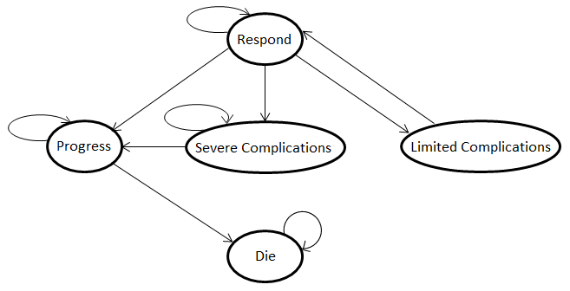

Section 2. Costs of Treatment and Complications in US dollars from the 2013 US MediCare Services Drug Payment Table and Physician Fee Schedule.

Table 1. Cost for cancer therapy and management of complications (Minion et al. 2015)
HEALTH STATES | CHEMORx ONLY |  | CHEMORx+BEVACIZUMAB
Cancer Therapy* | $524 |  | $7,540
Treatment of Hypertension** | $285 |  | $285
Weighted Thromboembolism*** | $4,261 x 3/4 |  | $4,261 x 18/31
Weighted Fistula**** | $16,000/3 x 1/4 |  | $16,000/3 x 13/31
 | Total Cost per 28-Day Cycle | Cost Breakdown | Total Cost per 28-Day Cycle | Cost  Breakdown
Respond | $524 |  | $7,540
Progress | $262 |  | $262
Limited complications | $809 | ChemoRx + Treatable hypertension | $7,825 | ChemoRx plus bevacizumab + Treatable hypertension
Severe complications | $4,076 | Weighted thromboembolism+ Weighted fistula/expected number of cycles | $4,240 | Weighted thromboembolism + Weighted fistula/expected number of cycles
Die | $0 | - | $0 | -
Table notes: *cost of chemo alone or chemo plus beva.; **cost of anti-hypertensive medication; ***cost of hospitalization, imaging studies, and anti-coagulation; weighted estimation based on analysis of adverse events from the primary manuscript; ****cost of imaging studies, colostomy and 3 days of hospitalization; weighted estimation based on analysis of adverse events. Note: Approximately 1 of every 3 patients who developed GI-vaginal fistula underwent fecal diversion via colostomy.

Section 3. Monthly transition probabilities estimated using recent clinical trial data⁽³⁻⁶⁾
Table 2. Transition probabilities of going to new health state given that a patient was in a prior health state at the end of the previous month (i.e., cycle) (Minion et al. 2015)
*probability assumed by authors based on treating physicians’ judgments. Typo from original table is corrected.
 | FROM i to j | Respond | Limited Complications | Progress | Severe Complications | Die
Chemo only | Respond | 0.8671 | 0.0024 | 0.1281 | 0.0024 | 0
 | Limited complications | 1* | 0* | 0 | 0 | 0
 | Progress | 0 | 0 | 0.8567 | 0 | 0.1433
 | Severe complications | 0 | 0 | 0.9* | 0.1* | 0
 | Die | 0 | 0 | 0 | 0 | 1
Chemo + Bevacizumab | Respond | 0.8720 | 0.0268 | 0.0858 | 0.0154 | 0
 | Limited complications | 1* | 0* | 0 | 0 | 0
 | Progress | 0 | 0 | 0.8660 | 0 | 0.1340
 | Severe complications | 0 | 0 | 0.9* | 0.1* | 0
 | Die | 0 | 0 | 0 | 0 | 1

Section 4. Analysis and results with decision tree with Markov nodes
A Markov decision tree was created in the Treeage Pro Healthcare Module software (Treeage.com). Note that the termination condition was set to 60 cycles which corresponds to 5 years. At this point in time, 99% of patients are expected to have died. (# sign indicates a probability = 1 – the sum of the other probabilities following a chance node circle).

The tree can be analyzed by “rolling back the tree” to compute the expected cost, the expected number of life months until death, and the expected number of quality adjusted life months until death. It can also be used to run a simulation of, e.g., 100 patients, with random draws from the probability distribution at each Markov or chance node. The monthly quality adjusted health utility levels were: Die: 0, Severe complications: .5; Limited complications, 0.75; Progress, 0.5; Respond, 1.
Figure 1A Markov decision tree. The overall structure of the Markov tree first has a decision between chemotherapy alone and chemotherapy plus bevacizumab (Minion et al.2015 ONLINE ONLY),
Panel A Terminal branching of the chemotherapy alone cohort.
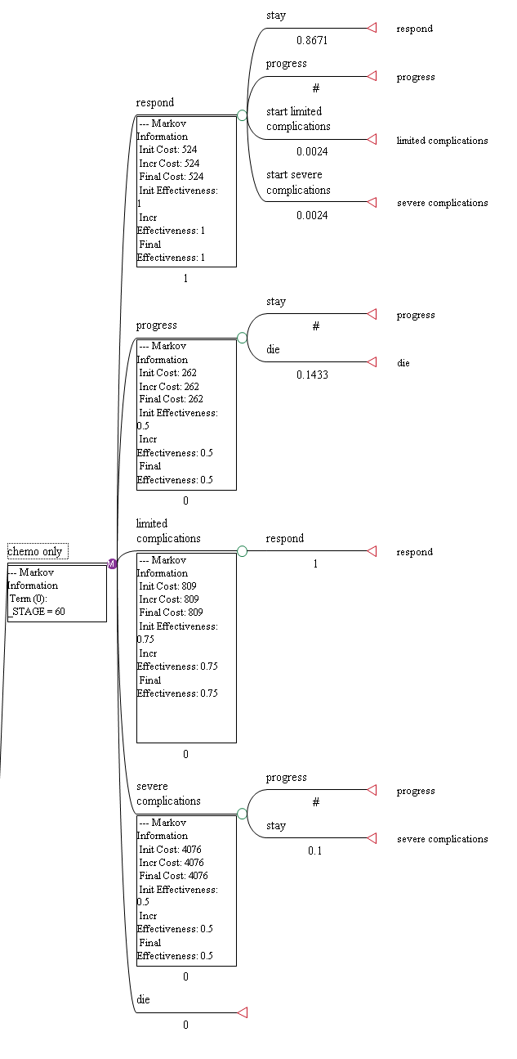
Panel B Terminal branching of the chemotherapy plus bevacizumab cohort.
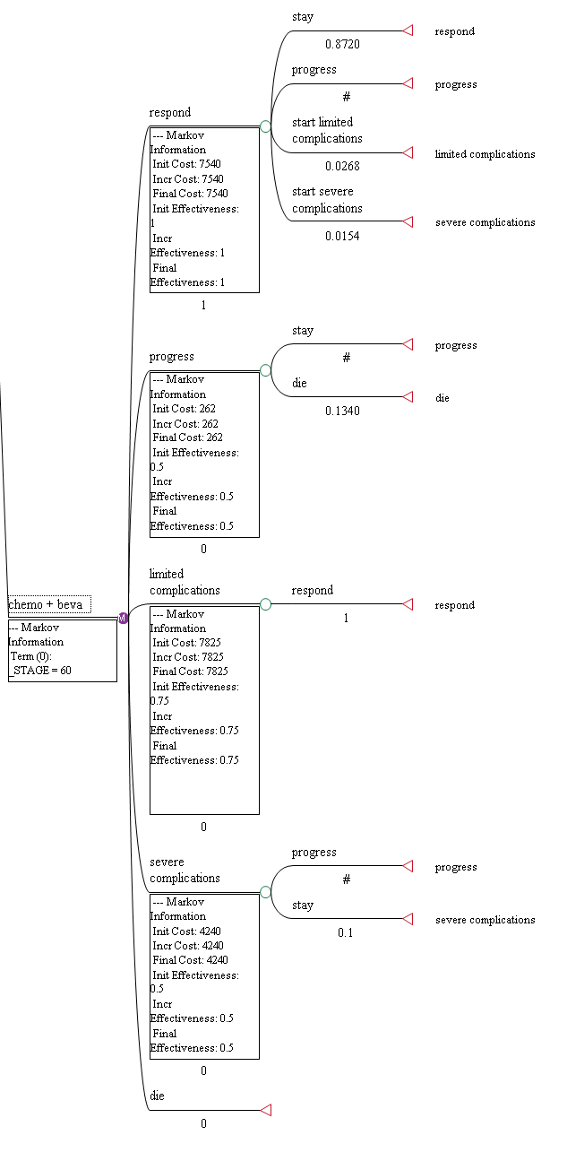
Figure 2. Cost effectiveness analysis of chemotherapy with and without bevacizumab in life months until death (Minion et al. 2015)

Figure 3. Cost-effectiveness of chemotherapy with and without bevacizumab for QALmonth and with projected reduction in cost of bevacizumab (Minion et al. 2015)

Conclusions
On average, patients survived 14.7 months at a US medical system cost of $5,938 with chemotherapy alone vs. 17.7 months at a cost of $79,097 with chemo plus bevacizumab. The estimated total cost of therapy with bevacizumab is approximately 13.3 times that for chemotherapy alone, adding $73,159 per 3.0 months of life gained. So the incremental cost effectiveness ratio (ICER) is $24,386 extra cost/extra month.
Patients experienced a health quality level each month depending on the treatment effectiveness and on any complications, ranging from 0 for death to 1 for the baseline of 1 month responding to advanced cervical cancer treatment. Patients survived 11.2 quality adjusted life months (QALmonths^{cc}) with chemo alone vs. 13.9 QALmonths^{cc} with chemo plus bevacizumab. The ICER ratio increased to $27,096/QALmonth^{cc} due to the smaller difference in QALmonths^{cc}.
Increased costs associated with bevacizumab therapy for advanced cervical cancer are primarily due to the cost of the drug and not the management of bevacizumab-induced complications. Possible future cost reductions in bevacizumab or biosimilars would result in dramatic declines in the added cost of gaining more months of life.
See Bai, del Campo and Keller (2016) for a review of software alternatives In our talk, we compare three software packages for Markov decision trees: TreeAge, Sto Tree by Godon Hazen, and the markovchain package in R.

Bibliography
- The talk is based on: Lindsey E. Minion, MD (Univ. of Arizona Cancer Center & Creighton University at St. Joseph’s Hospital and Medical Center, Phoenix); Jiaru Bai (Merage doctoral student); Bradley J. Monk, MD (Gynecologic Oncology, UCI); L. Robin Keller, PhD; Ramez N. Eskander, MD (Gynecologic Oncology, UCI); Gareth K. Forde, MD, PhD, MBA (Gynecologic Oncology, UCI) ; John K. Chan, MD (California Pacific Palo Alto Medical Foundation, Sutter Cancer Institute, San Francisco), Krishnansu S. Tewari (Gynecologic Oncology, UCI), “A Markov Model to Evaluate Cost-Effectiveness of Antiangiogenesis Therapy Using Bevacizumab in Advanced Cervical Cancer”, Gynecologic Oncology, Vol. 137, Issue 3, June 2015, pages 490-496.
http://www.sciencedirect.com/science/article/pii/S0090825815006769#
- FDA News Release. FDA approves Avastin to treat patients with aggressive and late-stage cervical cancer. August 14, 2014. http://www.fda.gov/NewsEvents/Newsroom/PressAnnouncements/ucm410121.htm.
- Monk BJ, Sill MW, McMeekin DS, Cohn DE, et al: Phase III trial of four cisplatin-containing doublet combinations in stage IVB, recurrent, or persistent cervical carcinoma: A Gynecologic Oncology Group study. J Clin Oncol 27:4649-55, 2009.
- Monk BJ, Sill MW, Burger RA, et al: Phase II trial of bevacizumab in the treatment of persistent or recurrent squamous cell carcinoma of the cervix: A Gynecologic Oncology Group study. J Clin Oncol 27:1069-74, 2009.
- Tewari KS, Sill MW, Long HJ 3rd, et al: Improved survival with bevacizumab in advanced cervical cancer. N Engl J Med 370:734-43, 2014.
- Penson RT, Huang HQ, Tewari KS, et al: Patient reported outcomes in a randomized trial of bevacizumab in the treatment of advanced cervical cancer: A Gynecologic Oncology Group study. Eur J Cancer 49:LBA 42, 2013 (suppl 3)
- Bai, J.R., del Campo, C., and Keller, L. R. (2016).:Modelos de Cadenas de Markov en la Practica: Una Revision de Opciones de Software de Bajo Coste, working paper, 2016, http://faculty.sites.uci.edu/lrkeller/cuban-operations-research-conference-2016/

